


UNIVERSITY OF GHANA
COLLEGE OF BASIC AND APPLIED SCIENCES

SCHOOL OF PHYSICAL AND MATHEMATICAL SCIENCES

DEPARTMENT OF STATISTICS

FINAL YEAR PROJECT

STAT 450(PROJECT)

TIME SERIES ANALYSIS OF FUEL PRICEING IN GHANA

BY

THEOPHILUS GYABAAH | 11038981
ADAMS EMMANUEL PADDY | 11264136
CHRIS OKWANING KORAM | 11345562

PROJECT SUPERVISOR: DOC. ISSAH SEIDU

CHAPTER ONE: INTRODUCTION

Background of the Study
Fuel is a foundational commodity essential for industrial production, transportation networks, and agricultural development, serving as a primary driver of global economic activity (Hamilton, 2009). Whether in the form of gasoline, diesel, or liquid petroleum gas (LPG), fuel acts as a non-negotiable input for generating energy and facilitating the movement of goods and services. Because of this structural reliance, the availability and pricing of petroleum products directly dictate the operational capacity and efficiency of contemporary economies.

Consequently, changes in fuel prices spread through the entire economy very quickly. Fluctuations impact the cost of living, drive inflation rates, alter business operating expenses, and ultimately shape the financial well-being of citizens (Hamilton, 2009). Given these cascading economic effects, the ability to accurately forecast price change is highly valuable for both macroeconomic planning and individual consumer behavior.

Globally, the price formation of fuel depends largely on crude oil markets. International crude oil prices, particularly the world benchmark price of Brent crude, historically exhibit high volatility due to geopolitical risks, OPEC supply decisions, global demand shifts, and macroeconomic factors (Kilian, 2009). This volatility has prompted an extensive amount of research into energy price prediction. Previous empirical studies have explored various time-series and econometric approaches to model these dynamics; for instance, Jammazi and Aloui (2012) utilized wavelet decomposition and neural networks for crude oil forecasting, while Baumeister and Kilian (2014) evaluated the macroeconomic impacts of oil price predictions.

The effects of this global fuel price volatility have been especially pronounced in Sub-Saharan Africa. Unlike developed nations with diverse energy portfolios and well-established price stabilization techniques, numerous African nations rely entirely on imported refined petroleum products. In these countries, international price shocks to crude oil transmit directly into domestic fuel prices (Alom et al., 2013). Furthermore, fluctuations in the exchange rate between their local currencies and the US dollar the international currency for the crude oil trade intensify the impact of foreign price shocks. Studies by Alom et al. (2013) using Structural Vector Autoregression (SVAR) models have demonstrated that these price shocks lead not only to direct economic volatility in developing countries but also to broader macroeconomic instability through imported inflation, which reduces consumer purchasing power.

Ghana serves as a prime example of this vulnerability. As an importer of refined petroleum products, Ghana's domestic fuel prices depend heavily on movements in international crude oil prices and the exchange rate between the Ghana cedi and the US dollar. The National Petroleum Authority (NPA), which oversees the downstream petroleum sector, fixes bi-weekly petrol, diesel, and LPG prices based on a price build-up formula considering international benchmark prices and exchange rates (National Petroleum Authority [NPA], 2023). A depreciation of the cedi which declined by 29.9% against the US dollar in 2022 alone combined with increased crude oil prices due to global conflicts, creates severe domestic price shocks. This sharp increase in global fuel prices caused domestic fuel prices to reach unprecedented levels, creating immense pressure on individuals and companies in Ghana (Bank of Ghana, 2023).

The interaction between fuel prices and inflation in Ghana introduces another layer of complexity. Higher fuel prices elevate production and distribution costs across virtually all industries, creating cost-push inflation. Because Ghana depends heavily on imported petroleum products, exchange rate depreciation creates additional amplification, driving up the domestic cost of fuel (Bawa et al., 2016). Inflationary pressures, in turn, affect consumer behavior and prompt monetary policy shifts, forming feedback loops. As a result, the effect of inflation on fuel prices is bidirectional; fuel prices, inflation, exchange rates, and crude oil prices must be considered together in a simultaneous multivariate time series (Hamilton, 2009).

Despite the economic importance of fuel price dynamics in Ghana, empirical literature on fuel price forecasting in the country remains underdeveloped. Most time series forecasting research in the sub-region focuses on broad commodity prices or general inflation indices rather than specific petroleum products (Addae & Ackah, 2017; Bawa et al., 2016). Crucially, very few studies consider how external factors specifically exchange rate shocks, international crude oil price movements, and inflationary dynamics affect the accuracy of fuel price forecasts. Time series models that ignore these external shocks may perform adequately under calm economic conditions but rapidly lose their predictive power during periods of economic crisis, which is precisely when accurate forecasting is most vital (Kilian, 2009).

This study aims to address this gap by developing and testing time series models for forecasting petrol, diesel, and LPG prices in Ghana, specifically evaluating exchange rate shocks, crude oil price movements, and inflationary dynamics as critical predictors of forecast performance.

Problem Statement
The prices of fuels in Ghana have remained highly volatile throughout the last ten years due to a combination of external and internal factors, namely fluctuating international crude oil prices, progressive depreciation of the Ghana cedi against the US dollar, and rising domestic inflation. This volatility has been exceptionally severe in recent years. Between the end of 2021 and the end of 2022, the price of petrol increased from ¢6.66 to ¢16.58 per liter (an increase of approximately 149%), while the diesel price increased from ¢6.67 to ¢19.61 per liter (an increase of about 194%) (Bank of Ghana, 2023). This rapid price escalation occurred concurrently with a 29.9% depreciation of the Ghana cedi against the US dollar and a surge in headline inflation to 54.1% by December 2022 (Ghana Statistical Service, 2023). Because fuel prices heavily influence the cost of transport services, food prices, industrial production, and public expenditure, this volatility imposes considerable financial pressure on Ghanaian households, businesses, and public institutions. Forecasting fuel price movements with reasonable precision over a six-month horizon would provide a highly valuable early warning system for consumers and policymakers.

A distinct characteristic of fuel pricing in Ghana is the Unified Pricing Formula (UPF) implemented by the National Petroleum Authority. The UPF calculates ex-pump fuel prices by aggregating international costs, exchange rate fluctuations, taxes, levies, and margins payable to Bulk Distribution Companies (BDCs) and Oil Marketing Companies (OMCs) (National Petroleum Authority [NPA], 2023). Because Ghanaian fuel prices are administratively determined based on international benchmarks rather than pure domestic supply and demand, they cannot be modeled using the exact same frameworks applied to fully deregulated energy markets.

Despite the critical need for fuel price stability in Ghana's economy, empirical studies focused specifically on forecasting domestic ex-pump petroleum prices are scarce. Existing research on African fuel price dynamics predominantly concentrates on international crude oil prices (Alom et al., 2013; Baumeister & Kilian, 2014), while studies focused on Ghana tend to analyze either inflation dynamics or general commodity prices (Addae & Ackah, 2017; Bawa et al., 2016). Accurately predicting domestic petroleum prices in Ghana requires a targeted approach, as international crude oil prices alone cannot account for the added volatility introduced by exchange rate movements, import costs, and local taxation.

Furthermore, while the Ghanaian market's reliance on exchange rates necessitates multivariate modeling, most of the existing research on energy price forecasting in Sub-Saharan Africa relies on univariate time series models, such as standard ARIMA (Jammazi & Aloui, 2012). Univariate models, which account only for internal price history, are highly susceptible to forecast bias during periods of external macroeconomic turbulence. There is a clear methodological gap regarding the comparison of univariate and multivariate models for fuel price series in Ghana, particularly concerning the explicit testing of external shocks on forecast accuracy.

This study seeks to fill this gap by developing, comparing, and evaluating univariate and multivariate time series models (ARIMA, ARIMAX, and VAR) for forecasting retail prices of petrol, diesel, and LPG in Ghana. Utilizing monthly data obtained from the National Petroleum Authority and the Bank of Ghana, the study will assess the extent to which incorporating exchange rate shocks, crude oil price movements, and inflationary dynamics improves forecast accuracy.

Objectives

Main Objective
To evaluate the forecasting accuracy of ARIMA, ARIMAX, and VAR models in predicting fuel prices in Ghana over a 1–6-month horizon, with an emphasis on the role of external shocks in determining model performance.

Specific Objectives

- To analyze the statistical properties and trends of petrol, diesel, and LPG prices in Ghana over the period 2015–2026.

- To develop ARIMA, ARIMAX, and VAR models for forecasting fuel prices, incorporating the exchange rate (GHS/USD), Brent crude oil prices, and inflation (CPI) as relevant external variables.

- To assess the influence of exchange rate and Brent crude oil shocks on fuel price movements in Ghana using Granger causality tests.

- To compare the forecasting accuracy of the three models across 1–6-month forecast horizons using RMSE, MAE, MAPE, and the Diebold-Mariano test.

- To evaluate the practical utility of the models in providing 1–6-month advance warning of fuel price changes to consumers and policymakers in Ghana.

Significance of the Study
The findings of this study will be of interest to various stakeholders such as policymakers, consumers, regulatory bodies, and the academic community. In particular, the paper offers the following contributions:

Policymakers and Government Agencies: The forecasting models developed in this study provide an empirical tool to assist proactive fiscal and energy policy decisions. By anticipating movements in fuel prices, government agencies can design timely interventions to cushion the economy against the adverse effects of price volatility.

The National Petroleum Authority (NPA): As the regulatory body responsible for fuel pricing in Ghana, the NPA stands to benefit directly from accurate short-term forecasts. These forecasts can help inform changes to the Unified Pricing Formula and allow for more transparent and data-driven pricing decisions.

Consumers and Households: Advance notice of changes in fuel prices provides households and firms with the opportunity to better plan their expenditure, especially since the cost of fuel directly affects the prices of goods, transportation, and other essential services.

Researchers and Academics: The study adds to the growing literature on time series forecasting in developing economies. The comparative framework employing ARIMA, ARIMAX, and VAR models in a unified Ghanaian setting offers a methodological reference for future research on commodity price forecasting in Sub-Saharan Africa.

Bulk Distribution Companies (BDCs): Fuel distributors can use price forecasts for procurement, inventory management, and pricing strategies, thereby reducing their exposure to supply-side shocks.

Methodology Overview
The study is based on secondary data collected from four primary sources. Monthly fuel prices for petrol, diesel, and LPG were obtained from the National Petroleum Authority (NPA) of Ghana. Exchange rate data (GHS/USD) were sourced from the Bank of Ghana, and Brent crude oil price data were acquired from the U.S. Energy Information Administration (EIA). Data on inflation, measured by the Consumer Price Index (CPI), were obtained from the Ghana Statistical Service (GSS). The study utilizes a monthly time series from July 2015 to June 2026, yielding 133 observations for each variable.

Fuel prices were forecasted using three time series models. As a univariate baseline model, we first fitted an autoregressive integrated moving average (ARIMA) model to each fuel price series. Secondly, an ARIMAX model was developed incorporating the exchange rate and Brent crude oil prices as external regressors to capture the effect of external shocks on fuel prices. Third, we estimated a Vector Autoregression (VAR) model to jointly model fuel prices with the exchange rate, Brent crude oil prices, and inflation (CPI), allowing for dynamic interactions among all variables.

Before the estimation of the models, all series were tested for stationarity using the Augmented Dickey-Fuller (ADF) test. Forecast accuracy was evaluated using standard metrics, including the Root Mean Square Error (RMSE), Mean Absolute Error (MAE), and Mean Absolute Percentage Error (MAPE).

All data processing, model estimation, and forecast evaluations were performed in Python (version 3.12.5). The libraries used include statsmodels (Seabold & Perktold, 2010) for the estimation of the ARIMA, ARIMAX, and VAR models; pandas (McKinney, 2010) for data manipulation; and matplotlib (Hunter, 2007) and seaborn (Waskom, 2021) for graphical visualization. Model diagnostic tests and forecast accuracy measures were calculated using built-in functions from the statsmodels and scikit-learn (Pedregosa et al., 2011) libraries.

Organization of the Study
The study is organized into five chapters. Chapter One provides the background of the study, the problem statement, objectives, the significance of the study, a brief overview of the methodology, and the organization of the study. Chapter Two presents a review of relevant literature, encompassing theoretical frameworks and empirical studies relevant to fuel price dynamics, time series forecasting, and the application of ARIMA, ARIMAX, and VAR models in commodity price forecasting. Chapter Three describes the methodology used for the study, detailing data sources, variable descriptions, model specifications, stationarity testing procedures, and forecast evaluation criteria. Chapter Four presents and discusses the results of the data analysis, including descriptive statistics, model estimation outputs, forecast performance, and a comparative evaluation of the three models. Finally, Chapter Five summarizes the key findings, draws conclusions, and offers recommendations for policymakers, regulatory authorities, and future researchers.

CHAPTER TWO: LITERATURE REVIEW

Introduction
This chapter reviews the theoretical and empirical foundations relevant to forecasting fuel prices in Ghana using ARIMA, ARIMAX, and VAR models. The chapter begins with a theoretical framework (Section 2.2), which explains the statistical and economic principles underlying the three modelling approaches. This is followed by an empirical review, structured to move from the general to the specific: global and international oil price forecasting studies (Section 2.3), studies from Sub-Saharan Africa and other developing economies (Section 2.4), and Ghana-specific studies (Section 2.5). Section 2.6 then narrows the focus further to studies that directly compare univariate and multivariate forecasting performance, since this comparison lies at the heart of the present study. Section 2.7 synthesizes these strands of literature to identify the specific research gap this study addresses, and Section 2.8 closes the chapter with a summary.

Theoretical Framework

Time Series Theory and Stationarity
A time series is a sequence of observations recorded sequentially over time, typically at fixed intervals. Most classical time series forecasting techniques, including ARIMA and VAR, rest on the assumption of stationarity a property whereby the statistical characteristics of a series, namely its mean, variance, and autocovariance structure, remain constant over time (Hamilton, 2009). A non-stationary series, by contrast, exhibits trends, changing variance, or other time-dependent structures that undermine the theoretical validity of forecasts derived from models built on the assumption of stability. Because most economic and commodity price series, including fuel prices, tend to display trending or volatile behaviour, testing for and correcting non-stationarity, typically through differencing, is a prerequisite step before model estimation. This principle underlies the "I" (Integrated) component of the ARIMA framework and motivates the use of stationarity tests, such as the Augmented Dickey-Fuller (ADF) test, prior to model building.

The Box-Jenkins Methodology and the ARIMA Model
The theoretical foundation for the Autoregressive Integrated Moving Average, ARIMA model derives from the Box-Jenkins methodology, a systematic three-stage iterative approach (identification, estimation, and diagnostic checking) for building univariate time series models (Box & Jenkins, 1970). An ARIMA(p,d,q) model expresses a variable's current value as a function of its own past values (the autoregressive, or "AR," component of order p), a moving average of past forecast errors (the "MA" component of order q), and a differencing operation of order d applied to induce stationarity. The strength of the ARIMA framework lies in its parsimony and its reliance solely on the internal history of the series being forecast, which makes it a natural baseline model against which more complex, information-rich models can be compared. Its principal theoretical limitation, however, is precisely this reliance on internal history: an ARIMA model has no mechanism for incorporating external shocks, such as a sudden currency depreciation or a spike in international crude oil prices, unless those shocks are already reflected in the series' own past behaviour by the time a forecast is made.

The ARIMAX Model
The Autoregressive Integrated Moving Average with Exogenous Variables, ARIMAX model extends the ARIMA framework by incorporating one or more exogenous explanatory variables directly into the model specification, allowing the forecast of the dependent variable to respond contemporaneously to movements in these external regressors. In the context of this study, the exchange rate (GHS/USD) and Brent crude oil prices are introduced as exogenous regressors, on the theoretical grounds that Ghana's domestic fuel prices are administratively derived from a price build-up formula that explicitly incorporates both variables (National Petroleum Authority [NPA], 2023). Theoretically, ARIMAX models are expected to outperform pure ARIMA models whenever the excluded exogenous variables carry meaningful, non-redundant information about future movements in the dependent variable, a proposition that several of the empirical studies reviewed in this chapter test directly.

Vector Autoregression (VAR)
Where ARIMA and ARIMAX treat the forecast variable as fundamentally dependent on external regressors in a one-directional sense, the Vector Autoregression (VAR) framework, developed by Sims (1980), treats all included variables as jointly and dynamically endogenous. In a VAR system, each variable is modelled as a function of its own lagged values and the lagged values of every other variable in the system, without imposing a priori restrictions on the direction of causality. This is theoretically well suited to the fuel price-inflation-exchange rate relationship in Ghana, where causality plausibly runs in multiple directions: fuel prices affect inflation through cost-push channels, while inflation and exchange rate movements simultaneously feed back into policy responses and import costs that affect fuel prices (Bawa et al., 2016; Hamilton, 2009). This theoretical property is precisely why CPI (inflation) is included only in the VAR specification in this study and deliberately excluded from the ARIMA and ARIMAX models: including a variable that is plausibly endogenous to fuel prices as a one-directional exogenous regressor risks biased and inconsistent estimates.

Oil Price Pass-Through and Exchange Rate Transmission
Beyond the purely statistical theory, this study is also grounded in the economic theory of price pass-through in import-dependent economies. Because Ghana imports the bulk of its refined petroleum products, international crude oil price changes and exchange rate movements are transmitted into domestic fuel prices through the cost structure embedded in the NPA's pricing formula (NPA, 2023). This transmission mechanism is well documented in the broader literature on oil price shocks in import-dependent developing economies, where currency depreciation compounds the domestic impact of rising international oil prices, since imports must be paid for in US dollars while domestic prices and wages are denominated in local currency (Alom et al., 2013; Kilian, 2009). This theoretical mechanism forms the economic justification for including both the exchange rate and Brent crude oil prices as external shock variables across all three models in this study.

Empirical Review: Global and International Oil Price Forecasting
International crude oil price forecasting has attracted substantial empirical attention for decades, largely because crude oil functions as a benchmark input whose volatility transmits into virtually every downstream petroleum market. A foundational contribution to this literature is Kilian's (2009) structural decomposition of oil price shocks, which distinguishes between shocks originating from crude oil supply disruptions, aggregate demand shifts, and oil-market-specific precautionary demand. This distinction matters for forecasting because each type of shock has different persistence and different macroeconomic consequences; a model that treats all price movements as homogeneous risks conflating transient supply disruptions with more persistent demand-driven trends. Kilian's framework has since become a standard reference point for researchers seeking to explain, rather than merely track, oil price volatility.
Hamilton (2009) complements this structural perspective with an applied macroeconomic account of the 2007-2008 oil price shock, documenting how the confluence of strong global demand and constrained supply capacity drove crude oil prices to historic highs, with cascading effects on inflation, consumer spending, and economic output in oil-importing economies. Hamilton's analysis is particularly relevant to the present study because it establishes, empirically, the transmission channel through which international crude oil price volatility affects downstream economic variables, a channel this study operationalizes directly by including Brent crude oil prices as an exogenous regressor in the ARIMAX and VAR models.
Methodologically, the literature has increasingly moved beyond univariate ARIMA benchmarks toward hybrid and machine-learning-augmented approaches. Jammazi and Aloui (2012) combined wavelet decomposition with neural network modelling to forecast crude oil prices, arguing that decomposing the price series into different frequency components before modelling improves the capture of both short-term volatility and longer-term trend behaviour, an approach that consistently outperformed standalone linear models in their study. Baumeister and Kilian (2014) took a more applied central-banking perspective, evaluating a range of forecasting approaches, including model averaging techniques, and concluding that no single method dominates across all forecast horizons; instead, forecast accuracy depends heavily on the horizon length and the specific economic conditions prevailing at the time of the forecast. This finding is directly relevant to the present study's decision to evaluate forecast accuracy across a full 1-6-month horizon rather than at a single fixed horizon, since horizon-dependent performance is a recurring theme in this literature.
Taken together, this stream of literature establishes two points that motivate the present study. First, oil price forecasting accuracy is highly sensitive to the underlying model's ability to incorporate external, non-price information, whether through structural shock decomposition, wavelet-based feature extraction, or exogenous regressors, rather than relying solely on a series' own past values. Second, forecast performance is not uniform across horizons, reinforcing the importance of horizon-specific evaluation. However, this literature is concentrated almost entirely on international benchmark crude prices (WTI, Brent, OPEC basket) rather than domestic, administratively set retail fuel prices of the kind studied here, a distinction that becomes central once the focus shifts to import-dependent economies in Sub-Saharan Africa, discussed next.

Empirical Review: Sub-Saharan Africa and Developing Economies
The dynamics documented in the global oil price literature take on a distinctive character once attention shifts to import-dependent developing economies, where domestic fuel prices are shaped not only by international crude oil movements but also by exchange rate volatility and, in many cases, administrative pricing mechanisms. Alom et al. (2013) provide an important cross-country perspective, applying structural vector autoregression (SVAR) models to examine how oil and food price shocks propagate through Asian and Pacific economies. Their findings show that these shocks generate not only direct price effects but also broader macroeconomic instability through imported inflation, which erodes consumer purchasing power, a transmission mechanism that closely parallels the exchange rate-dependent price formation process in Ghana's own petroleum sector. Critically, their use of an SVAR framework, rather than a purely univariate approach, reflects a broader methodological pattern in the literature on developing economies: because external shocks and domestic prices are jointly determined, multivariate frameworks are increasingly preferred over univariate ones when the research question centres on shock transmission rather than pure extrapolation.
This pattern is echoed directly in the West and East African petroleum forecasting literature. Biu et al. (2024) compared ARIMA and ARIMAX models for four petroleum products (PMS, kerosene, aviation fuel, and diesel) in Nigeria, using twelve years of monthly sales data. Their results showed that ARIMAX models, incorporating each product's relationship with the other three petroleum products as exogenous regressors, outperformed pure ARIMA models on standard accuracy measures (MAE, MSE, RMSE) for three of the four products, a result the authors attributed to the ARIMAX specification's ability to capture cross-product substitution and shared cost pressures that a univariate ARIMA model, by construction, cannot. Similarly, in Kenya, Fondo et al. (2021, as cited in Gasper & Mbwambo, 2023) modelled petroleum prices using both ARIMA and VAR frameworks and found that the VAR model produced the lowest forecast error, leading the authors to recommend VAR as the superior model for petroleum price forecasting in that context.
Taken together, the Nigerian and Kenyan evidence point toward a consistent regional finding: in African petroleum markets, models that incorporate external or cross-variable information, whether through exogenous regressors (ARIMAX) or fully endogenous multivariate systems (VAR), tend to outperform univariate ARIMA benchmarks. This is a meaningful pattern for the present study, since it suggests the improvement from ARIMA to ARIMAX to VAR observed elsewhere in the region may plausibly extend to the Ghanaian case. However, three limitations in this regional literature are worth noting. First, none of these studies directly compares all three model classes (ARIMA, ARIMAX, and VAR) within a single, unified study; each paper compares at most two. Second, none of them is set in Ghana specifically, where the administratively determined Unified Pricing Formula introduces a distinctive institutional feature not present in Nigeria's more market-driven post-subsidy pricing environment. Third, none explicitly isolates and tests the forecast-accuracy contribution of exchange rate shocks as a standalone variable of interest, a gap the next section examines in the specific context of Ghana.

Empirical Review: Ghana-Specific Studies
The Ghana-specific fuel price forecasting literature has grown steadily, but a close reading of it reveals a persistent methodological pattern that this study directly addresses. Addae and Ackah (2017) examined inflation dynamics in Ghana across the pre- and post-deregulation eras, investigating whether petroleum price movements exert measurable influence on domestic inflation. Their work, alongside Bawa et al.'s (2016) broader analysis of inflation dynamics in the West African context, establishes the empirical link between fuel prices and inflation in the region, providing part of the theoretical justification for treating CPI as an endogenous variable within the VAR component of the present study rather than as an exogenous ARIMAX regressor.
Turning specifically to fuel price forecasting studies in Ghana, an early and instructive precedent is Okyere's (2012) bachelor's thesis, which built a Seasonal ARIMA model for monthly petroleum prices in Ghana using data from January 1990 to September 2010. The study identified ARIMA(1,1,5)×(1,0,1)₁₁ as its best-fitting model and concluded that petroleum prices were likely to see only insignificant increases in the following months, a forecast that, with the benefit of hindsight, badly understated the volatility Ghana's fuel prices would go on to exhibit. More importantly for this review, the study was purely univariate: no exchange rate, crude oil price, or inflation variable was incorporated, despite the NPA's pricing formula already depending explicitly on these external factors at the time.
More recent Ghanaian studies show that this univariate tendency has persisted even as methodological sophistication has increased elsewhere. Agyare et al. (2024) compared ARIMA and SARIMA models for forecasting gasoline and diesel prices in Ghana using monthly data from January 2016 to December 2023, drawn from the same institutional sources (Bank of Ghana and NPA) used in the present study. Evaluating forecast accuracy with RMSE, MAE, and MAPE, they found that SARIMA models generally outperformed standard ARIMA models for both fuels, with one minor exception in diesel RMSE. In a related follow-up study, Agyare et al. (2025) extended this line of work by developing a hybrid model combining ARIMA with a nonlinear autoregressive neural network (NARNN-LSTM) for the same fuels and data sources, finding that while ARIMA alone outperformed the standalone neural network model, the hybrid ARIMA-NARNN-LSTM specification outperformed both base models substantially.
These two studies are notable for how closely their data, period, and institutional sources mirror those of the present study, which makes the absence of any exogenous or multivariate specification in either paper particularly striking. Both papers remain confined to variations of a single explanatory paradigm: the current fuel price explained purely by its own past values (or a decomposed/hybridized version of that same history), whether through seasonal differencing (SARIMA) or nonlinear pattern recognition (NARNN-LSTM). Neither study tests whether directly incorporating the exchange rate or Brent crude oil price, the two variables the NPA's own pricing formula relies on, would improve forecast accuracy beyond what SARIMA or hybrid neural approaches achieve. Similarly, neither compares a VAR specification capable of capturing the joint, bidirectional dynamics between fuel prices, the exchange rate, and inflation that Ghana's price build-up formula and broader macroeconomic literature (Bawa et al., 2016) suggest should exist.
This gap is thrown into sharper relief by Agyapong et al.'s (2024) Ghana-specific exchange rate forecasting study, which demonstrates that Bayesian model averaging techniques applied to the GHS/USD exchange rate achieve their best forecast accuracy at the 3-month horizon, closely overlapping with the 1–6-month horizon adopted in the present study. Their work confirms that the exchange rate itself is forecastable with reasonable accuracy over the same horizon this study is concerned with, but their analysis stops short of asking what happens once exchange rate forecasts are fed forward into fuel price models, precisely the multivariate linkage this study investigates through ARIMAX and VAR.
Taken together, the Ghana-specific literature confirms two things: first, that the data infrastructure and institutional sources (BoG, NPA) needed for this kind of study are well established and have already been used successfully in closely related work; and second, that despite this, no existing Ghanaian study has directly compared ARIMA, ARIMAX, and VAR within a single framework using exchange rate, Brent crude, and CPI as external shock variables across a full 1–6-month forecast horizon. This is the specific gap the present study is designed to fill.

Comparative Studies: ARIMA vs. ARIMAX vs. VAR
The preceding sections have already surfaced the core comparative evidence relevant to this study's central methodological question: does moving from a univariate to a multivariate specification meaningfully improve fuel price forecast accuracy? This section draws that evidence together explicitly and adds one further comparative study from outside the energy sector to test whether the pattern holds more generally.
Across the studies reviewed so far, a consistent but not unconditional pattern emerges, models that incorporate external information, whether through exogenous regressors (ARIMAX) or full multivariate endogeneity (VAR), tend to outperform pure univariate ARIMA benchmarks, but the margin of improvement is neither uniform across variables nor guaranteed. Biu et al. (2024) found that ARIMAX outperformed ARIMA for three of four Nigerian petroleum products (PMS, kerosene, and diesel) but that ARIMA performed better for the fourth (aviation turbine kerosene), a result the authors attributed to weaker cross-product relationships for that particular fuel. This finding is a useful caution against assuming multivariate superiority is automatic: it depends on whether the chosen exogenous variables actually carry meaningful explanatory power for the specific series being forecast.
The evidence on VAR specifically points in a similar direction, though drawn from a smaller pool of studies. Fondo et al. (2021, as cited in Gasper & Mbwambo, 2023) found that a VAR model incorporating exchange rate, inflation, and crude oil price information outperformed a univariate ARIMA benchmark for petroleum price forecasting in Kenya, based on RMSE, MAE, and MAPE. Outside the energy sector, Ali and Saleh (2023) directly compared VAR and ARIMAX specifications for forecasting Iraqi government spending and foreign reserves, two macroeconomic series with a documented dynamic interdependence, and likewise found the VAR specification to be the more efficient forecasting model overall. Notably, this is one of the few studies in the reviewed literature that compares VAR and ARIMAX directly against one another, rather than each against a univariate ARIMA baseline, and its conclusion (that a fully endogenous, jointly-modelled system outperforms a specification treating explanatory variables as one-directionally exogenous) lends support to the theoretical rationale, discussed in Section 2.2.4, for including inflation only within the VAR component of the present study, where its plausible bidirectional relationship with fuel prices can be properly accommodated.
Three observations follow from synthesizing this comparative evidence. First, the general direction of the literature favours multivariate approaches over univariate ones, but exceptions exist and appear to be driven by the strength of the relationship between the forecast variable and the chosen external variables, not by any inherent superiority of multivariate models in all circumstances. Second, the relative performance of ARIMAX versus VAR specifically remains under-tested: most studies compare one multivariate approach against a univariate ARIMA baseline, but very few studies, and none identified in the Ghanaian or wider West African context, compare ARIMAX and VAR directly against each other, let alone against ARIMA in the same unified framework. Third, no study reviewed here evaluates comparative forecast accuracy across multiple horizons (1 through 6 months) for fuel prices specifically, despite Baumeister and Kilian's (2014) finding, discussed in Section 2.3, that forecast accuracy and the relative ranking of competing models is often horizon dependent. These three observations, taken together, define precisely the methodological gap this study is positioned to close.

Research Gap
Synthesizing the four strands of literature reviewed in this chapter reveals a gap that is precise rather than broad, defined at the intersection of geography, data granularity, and modelling scope.
From the global literature (Section 2.3): international crude oil forecasting is a mature field, but its focus on benchmark prices (WTI, Brent, OPEC basket) means its findings, while theoretically foundational, do not directly address domestic, administratively determined retail fuel prices of the kind set by Ghana's NPA. The transmission mechanism from crude oil to domestic prices is assumed rather than tested in this literature.
From the regional African literature (Section 2.4): studies from Nigeria and Kenya demonstrate that multivariate approaches (ARIMAX, VAR) generally outperform univariate ARIMA for petroleum price forecasting, but each study tests at most two model classes against each other, never all three. None is set in Ghana, where the Unified Pricing Formula constitutes a distinctive institutional pricing mechanism not replicated in Nigeria's post-subsidy market-driven system or Kenya's regulatory environment.
From the Ghana-specific literature (Section 2.5): the closest precedents to this study, Agyare et al. (2024, 2025), use nearly identical data sources and time periods but remain confined to univariate and hybrid machine-learning specifications (ARIMA, SARIMA, NARNN-LSTM). Despite the NPA's own pricing formula explicitly depending on the exchange rate and international crude oil prices, no Ghanaian fuel price forecasting study has directly incorporated these as exogenous regressors or modelled them jointly with fuel prices in a VAR framework.
From the comparative modelling literature (Section 2.6): direct three-way comparisons of ARIMA, ARIMAX, and VAR are rare across the literature generally, and non-existent for Ghanaian fuel prices specifically. Where ARIMAX and VAR have been compared directly (Ali & Saleh, 2023), the evidence favours VAR's fully endogenous treatment of macroeconomic interdependence, but this finding has not been tested in the fuel price context. Furthermore, no study identified in this review evaluates forecast accuracy across a full 1–6-month horizon for fuel prices, despite established evidence that model performance is horizon-dependent (Baumeister & Kilian, 2014).
The precise gap, therefore, is this: no existing study evaluates ARIMA, ARIMAX, and VAR within a single, unified comparative framework for Ghanaian retail fuel prices (petrol, diesel, LPG), incorporating the exchange rate and Brent crude oil price as external shock variables, assessed systematically across a 1–6-month forecast horizon using standard accuracy measures and formal forecast-comparison tests.

How This Study Addresses the Gap
This study is designed to close each dimension of the gap identified above directly. The absence of a three-way ARIMA/ARIMAX/VAR comparison for fuel prices is addressed by estimating and comparing all three models within one unified framework (Objectives 2 and 4). The tendency of Ghana-specific studies to remain univariate is addressed by incorporating the exchange rate and Brent crude explicitly as ARIMAX regressors, directly testing whether they improve on the univariate baselines used in prior Ghanaian studies (Objectives 2 and 3). The untested bidirectional relationship between inflation and fuel prices in this context is addressed by including CPI only in the VAR specification, consistent with the endogeneity concerns raised in Section 2.2.4, rather than forcing it into a one-directional exogenous role (Objective 2). The absence of horizon-specific evaluation for fuel prices is addressed by assessing forecast accuracy (RMSE, MAE, MAPE) and the statistical significance of differences between models (Diebold-Mariano test) separately across the full 1–6-month horizon, rather than at a single forecast point (Objective 4). Finally, the gap between statistical findings and their practical value is addressed by explicitly evaluating the practical utility of the best-performing model for giving consumers and policymakers advance notice of price changes (Objective 5).
In short, this study does not introduce an entirely new modelling technique; ARIMA, ARIMAX, and VAR are all well-established methods individually. Its contribution lies in bringing all three together, for the first time, into a single rigorous comparison calibrated specifically to Ghana's fuel market structure, external shock exposure, and the exact forecast horizon that matters most for practical early-warning purposes.

Chapter Summary
This chapter reviewed the theoretical and empirical foundations underpinning this study. Section 2.2 established the statistical and economic theory behind ARIMA, ARIMAX, and VAR, explaining why each model behaves as it does and providing the theoretical justification for this study's specific design choices, particularly the restriction of CPI to the VAR specification alone. Sections 2.3 through 2.5 reviewed the empirical literature at progressively narrower levels of focus, moving from global crude oil forecasting, through regional African studies, to Ghana-specific fuel price research. Section 2.6 synthesized the comparative evidence on model performance across this literature, while Section 2.7 used that synthesis to define a precise research gap: no existing study compares ARIMA, ARIMAX, and VAR within a single framework for Ghanaian fuel prices, incorporating exchange rate and Brent crude oil shocks, across a full 1–6-month forecast horizon.
Having established both the theoretical basis and the empirical justification for this study, the next chapter details the methodology used to address this gap: the data sources and variable definitions, the specific model formulations, the stationarity and diagnostic testing procedures, and the forecast evaluation criteria that will be applied in Chapter 4.

CHAPTER THREE: RESEARCH METHODOLOGY

Introduction
This chapter presents the methodological framework adopted for modelling and forecasting petrol, diesel, and liquefied petroleum gas (LPG) prices in Ghana. It details the research design, the sources and nature of the data employed, the definition and measurement of the study variables, the procedures followed in preparing the data for analysis, and the statistical and econometric techniques used to achieve the objectives set out in Chapter One. The chapter further describes the tests conducted to assess the stationarity of the series, the specification of the Autoregressive Integrated Moving Average (ARIMA), ARIMA with Exogenous Variables (ARIMAX), and Vector Autoregression (VAR) models, the criteria used for model selection and diagnostic checking, and the metrics used to evaluate forecast accuracy. The chapter closes with a discussion of the ethical considerations that guided the conduct of the study.

Methodology
This study adopts a quantitative research design underpinned by the positivist research paradigm, which holds that patterns in fuel-price behaviour can be objectively measured, modelled, and predicted using historical numerical data (Creswell & Creswell, 2018). The specific design employed is an applied, correlational, and predictive time series design. It is applied because the study seeks to solve a practical forecasting problem for the stakeholders identified in Chapter One; correlational because it examines the extent to which fuel prices co-move with exchange rate movements, international crude oil prices, and inflation; and predictive because its ultimate output is a set of validated models capable of generating out-of-sample forecasts of petrol, diesel, and LPG prices over 1- to 6-month horizons.
Time series designs differ from cross-sectional survey designs in that the unit of analysis is not an individual respondent but a chronologically ordered sequence of observations of the same variable(s) over time. Because the design relies on time-ordered secondary data rather than data collected directly from human participants, the sampling considerations that would apply in a survey-based study do not apply here. Instead, the key methodological concerns are the length, frequency, and completeness of the historical record; the stationarity properties of each series; and the temporal dependence structure that the ARIMA, ARIMAX, and VAR models are designed to capture (Box, Jenkins, Reinsel, & Ljung, 2015).

Data Type and Sources of Data
The study relies entirely on secondary, quantitative, time-ordered (longitudinal) data compiled from four official sources, consistent with the data sources outlined in Chapter One:
1. Fuel pump prices: Monthly average retail prices (in Ghana cedis) for petrol (GHS/litre), diesel (GHS/litre), and LPG (GHS/kilogram) were compiled from the National Petroleum Authority (NPA), the statutory body responsible for fixing and publishing ex-pump petroleum prices in Ghana under the Unified Petroleum Pricing Formula.
2. Exchange rate: The monthly average interbank exchange rate of the Ghana cedi to the United States dollar (GHS/USD) was obtained from the Bank of Ghana (BoG).
3. International crude oil price: The monthly average Brent crude oil spot price (USD per barrel) was obtained from the U.S. Energy Information Administration (EIA).
4. Inflation: Monthly Consumer Price Index (CPI) figures were obtained from the Ghana Statistical Service (GSS).
The four series were merged into a single monthly panel indexed by calendar month. Following the data screening procedures described in Section 3.6, the working dataset comprises 132 complete monthly observations spanning July 2015 to June 2026, providing a sufficiently long historical record to identify seasonal and cyclical patterns while capturing major structural events relevant to Ghana's fuel market, including the 2015 downstream petroleum deregulation, the 2020 COVID-19 demand shock, and the 2022-2023 currency depreciation and inflation crisis discussed in Chapter One.

Description and Measurement of Variables
Table 3.1 summarises the six variables used in the study, their units of measurement, their role in the analysis, and their respective data sources. The three fuel price series (PETt, DSLt, LPGt) constitute the dependent variables modelled separately under each of the three modelling frameworks. The exchange rate (EXRt) and Brent crude oil price (BRTt) enter the ARIMAX specifications as exogenous regressors, while all six variables enter jointly and symmetrically into the VAR system described in Section 3.9.3.

Variable | Symbol | Unit of Measurement | Role in the Study | Source
Petrol price | PETt | GHS per litre | Dependent (target) variable | NPA
Diesel price | DSLt | GHS per litre | Dependent (target) variable | NPA
LPG price | LPGt | GHS per kilogram | Dependent (target) variable | NPA
Brent crude oil price | BRTt | USD per barrel | Independent / exogenous regressor | EIA
Exchange rate | EXRt | GHS per USD | Independent / exogenous regressor | Bank of Ghana
Consumer Price Index | CPIt | Index points | Independent / exogenous regressor | GSS
Table 3.1: Description and Measurement of Study Variables

Data Collection Procedure
Because the study relies on secondary data, no primary instrument (questionnaire or interview schedule) was designed or administered. Data collection instead involved a structured desk-review and retrieval exercise comprising: (i) archival retrieval of officially published monthly pump-price bulletins from the NPA; (ii) retrieval of the monthly average interbank exchange rate series from the Bank of Ghana's statistical database; (iii) download of the monthly Europe Brent Spot Price FOB series from the EIA's public petroleum data portal; and (iv) retrieval of the monthly Consumer Price Index bulletins published by the Ghana Statistical Service. Where the NPA published prices on a bi-weekly basis, values were averaged within each calendar month to obtain a single monthly observation consistent with the monthly frequency of the other three series. The four series were then merged by calendar month into a single master spreadsheet used for all subsequent analysis.

Data Preprocessing and Cleaning
Prior to model estimation, the merged dataset was screened and cleaned following standard time series data preparation procedures (Hyndman & Athanasopoulos, 2021):
1. Completeness check: the raw file was inspected for blank rows and out-of-range dates; a single trailing blank row containing no month label and no observations was identified and removed.
2. Consistency check: calendar months were confirmed to be sequential and non-duplicated across the sample period, with no gaps in the monthly sequence.
3. Missing-value treatment: a single missing Consumer Price Index observation was identified in the final month of the sample (June 2026), reflecting the fact that the Ghana Statistical Service had not yet published the CPI bulletin for that month at the time data collection was concluded. Because this missing value occurs at the boundary of the series rather than internally, it was addressed by carrying forward the last observed value for descriptive and graphical purposes, while the affected month was excluded from CPI-dependent multivariate (VAR) estimation windows. Where an internal (non-boundary) missing value occurs in any series, linear interpolation between adjacent months is applied instead.
4. Outlier and structural break screening: each series was visually inspected using time plots and boxplots to identify implausible values. Extreme observations coinciding with known real economic events (for example, the 2022 currency depreciation) were retained, since these reflect genuine market conditions rather than recording errors, consistent with the study's objective of evaluating model performance under shock conditions.
5. Unit and scale verification: all fuel price series were confirmed to be denominated in Ghana cedis on a consistent litre or kilogram basis, and the Brent crude series was confirmed to be in United States dollars per barrel, consistent with Section 1.5; no unit conversion was required.
6. Train-test partitioning: to support the evaluation of 1- to 6-month-ahead forecast accuracy (Objective 4), the cleaned series were partitioned chronologically into a training (estimation) set, comprising all observations except the final six months, and a hold-out test set comprising the last six-monthly observations. Models were estimated exclusively on the training set and evaluated on their ability to forecast the withheld test-set observations, ensuring an out-of-sample rather than in-sample assessment of forecast accuracy.

Exploratory Data Analysis
Prior to formal model building, each series was explored descriptively to characterise its statistical and temporal properties. This involved: (i) computation of descriptive statistics (mean, standard deviation, minimum, maximum, skewness, and kurtosis) for each variable; (ii) visual inspection of time plots to identify trend, seasonality, level shifts, and volatility clustering; (iii) construction of a Pearson correlation matrix to assess the strength and direction of the linear association between fuel prices and the exchange rate, Brent crude price, and CPI; and (iv) seasonal-trend decomposition using Loess (STL) to separate each fuel price series into trend, seasonal, and residual components. These exploratory results, presented in Chapter Four, informed the subsequent choice of differencing order and model structure.

Stationarity Testing
A core requirement for classical ARIMA, ARIMAX, and VAR modelling is that the series being modelled is, or can be transformed to be, weakly (covariance) stationary - that is, its mean, variance, and autocovariance structure do not change over time (Box et al., 2015). Because fuel prices, the exchange rate, Brent crude prices, and CPI are all known to trend over the sample period, each series was formally tested for the presence of a unit root using the Augmented Dickey-Fuller (ADF) test (Dickey & Fuller, 1979).
The ADF test is based on the regression:
ΔYt = α + βt + γYt-1 + Σ(i=1 to k) δi ΔYt-i + εt
where Yt is the series under investigation, ΔYt = Yt - Yt-1 is its first difference, t is a linear time trend, k is the number of lagged difference terms included to correct for serial correlation in the residuals (selected using the Akaike Information Criterion), and εt is a white-noise error term. The test evaluates the following hypotheses:
H0: γ = 0 (the series has a unit root and is non-stationary)
H1: γ < 0 (the series is stationary)
A series was judged non-stationary whenever the ADF test failed to reject H0 at the 5% significance level (p > 0.05). Non-stationary series were differenced (Yt - Yt-1) and re-tested; this procedure was repeated until stationarity was achieved, with the number of differences required recorded as the order of integration, d, for that series. As a robustness check, the Kwiatkowski-Phillips-Schmidt-Shin (KPSS) test (Kwiatkowski, Phillips, Schmidt, & Shin, 1992), whose null hypothesis is stationarity (the reverse of the ADF null), was also applied to each series; agreement between the ADF and KPSS conclusions was used to confirm the stationarity status and appropriate differencing order of each series before proceeding to model estimation.

Model Specification

Univariate ARIMA Models
Consistent with Objective 2 and following the classical Box-Jenkins methodology (Box et al., 2015), a univariate Autoregressive Integrated Moving Average, ARIMA(p, d, q), model was first fitted to each of the three fuel price series individually, serving as a baseline against which the added value of incorporating external variables (ARIMAX) and cross-variable dynamics (VAR) could be judged. The general ARIMA(p, d, q) model for a series Yt integrated of order d is specified as:
φ(B)(1-B)^d Yt = θ(B)εt
where B is the backshift operator (BYt = Yt-1), φ(B) = 1 - φ1B - φ2B² - ... - φpB^p is the autoregressive polynomial of order p, θ(B) = 1 + θ1B + θ2B² + ... + θqB^q is the moving-average polynomial of order q, d is the order of differencing established in Section 3.8, and εt is assumed to be white noise with zero mean and constant variance σ².
Model building followed the standard three-stage Box-Jenkins procedure:
1. Identification: candidate orders p and q were identified by inspecting the autocorrelation function (ACF) and partial autocorrelation function (PACF) of the (differenced, stationary) series, and cross-checked against an automated, AIC-minimizing grid search over candidate orders implemented in Python.
2. Estimation: the parameters of each candidate model were estimated by maximum likelihood estimation (MLE).
3. Diagnostic checking: the residuals of each fitted model were examined for remaining autocorrelation and non-normality (Section 3.11); models that failed diagnostic checks were discarded and the identification stage revisited.
Among all candidate models that passed diagnostic checking, the model with the lowest Akaike Information Criterion (AIC) was retained as the preferred ARIMA specification for each series, consistent with the model-selection criteria described in Section 3.10.

ARIMAX Model
To address Objective 2 more directly - specifically, the incorporation of exchange rate and Brent crude oil price movements as external shocks - an ARIMAX(p, d, q) model was estimated for each fuel price series, extending the univariate ARIMA specification with exogenous regressors:
φ(B)(1-B)^d Yt = β1 EXRt + β2 BRTt + θ(B)εt
where EXRt and BRTt are the exchange rate and Brent crude oil price at time t, respectively, and β1 and β2 are the regression coefficients capturing the effect of a one-unit change in the exchange rate and Brent crude price on the fuel price series, holding the autoregressive and moving-average structure constant. Lagged values of the exogenous regressors were also considered where cross-correlation analysis indicated a delayed, rather than contemporaneous, transmission of external shocks into pump prices, consistent with the administratively lagged nature of the Unified Petroleum Pricing Formula discussed in Chapter One. The order (p, d, q) of the ARIMA component was re-identified for the ARIMAX specification using the same AIC-minimization procedure described in Section 3.9.1, applied to the regression residuals after removing the linear effect of the exogenous regressors.

Vector Autoregression (VAR) Model
To capture the dynamic, bidirectional interdependence among fuel prices, the exchange rate, Brent crude oil prices, and inflation - and to directly test Objective 3 using Granger causality - a Vector Autoregression, VAR(p), model was estimated jointly over the vector of variables Zt = [PETt, DSLt, LPGt, EXRt, BRTt, CPIt]', or an appropriately reduced subset where necessary to preserve degrees of freedom given the sample size. The reduced-form VAR(p) model is specified as:
Zt = c + A1 Zt-1 + A2 Zt-2 + ... + Ap Zt-p + ut
where c is a vector of intercepts, A1 through Ap are coefficient matrices capturing the effect of each variable's own and cross-variable lags on the current values of all variables in the system, p is the VAR lag order, and ut is a vector white-noise error term, allowing for contemporaneous correlation across equations but no serial correlation over time.
1. Lag order selection: the optimal lag length p was selected by estimating the VAR system across a range of candidate lag orders (1 to 12 months, reflecting the monthly frequency of the data) and comparing the Akaike Information Criterion (AIC), Bayesian Information Criterion (BIC), Hannan-Quinn Information Criterion (HQIC), and the Final Prediction Error (FPE) statistic across candidates; the lag order minimising the majority of these criteria was selected.
2. Stability check: the fitted VAR system was tested for stability by verifying that all eigenvalues (moduli) of the companion matrix of the estimated coefficients lie strictly inside the unit circle; an unstable VAR would produce explosive, non-sensical long-run forecasts.
3. Granger causality testing: to directly address Objective 3, pairwise Granger causality (Wald) tests (Granger, 1969) were conducted on the fitted VAR system. A variable X is said to Granger-cause a variable Y if past values of X contain statistically significant information for predicting Y, over and above the information contained in past values of Y alone. This was tested via the null hypothesis that all coefficients on the lagged values of X are jointly zero in the equation for Y, H0: a1 = a2 = ... = ap = 0 (X does not Granger-cause Y), evaluated using an F-test at the 5% significance level. Separate Granger causality tests were conducted for the exchange rate to fuel price, Brent crude price to fuel price, and, as a robustness check, the reverse directions, to establish the direction of causality between the domestic and external variables.

Model Selection Criteria
Across all three modelling frameworks (ARIMA, ARIMAX, and VAR), model parsimony and out-of-sample forecasting performance were balanced using standard information criteria that penalise excessive model complexity:
AIC = -2 ln(L) + 2k
BIC = -2 ln(L) + k ln(n)
where L is the maximized value of the likelihood function, k is the number of estimated parameters, and n is the number of observations. Because BIC imposes a heavier penalty on additional parameters than AIC once n > 7, it was used as a secondary check against overfitting whenever AIC favored a substantially more complex model without a meaningful improvement in fit. Among competing specifications that passed the residual diagnostic tests described in Section 3.11, the specification with the lowest AIC, with BIC reported as a robustness check, was retained as the final model for each series.

Residual Diagnostic Checking
Once a model was estimated, its residuals were subjected to a battery of diagnostic tests to verify that the model had adequately captured the systematic structure of the data, consistent with the third stage of the Box-Jenkins methodology:
1. Ljung-Box (portmanteau) test: tests the null hypothesis that residuals are independently distributed (no remaining autocorrelation) up to lag m: Q = n(n+2) Σ(k=1 to m) [ρ̂k² / (n-k)], where ρ̂k is the sample autocorrelation of the residuals at lag k. A significant Q-statistic (p < 0.05) indicates that the model has not fully captured the autocorrelation structure of the series and requires re-specification.
2. ARCH-LM test: tests for remaining autoregressive conditional heteroskedasticity (volatility clustering) in the residuals (Engle, 1982); significant ARCH effects would suggest that a volatility model, such as GARCH, may be warranted as an extension.
3. Jarque-Bera test: tests the null hypothesis that residuals are normally distributed, based on the sample skewness and kurtosis of the residuals (Jarque & Bera, 1980); while normality is not strictly required for parameter consistency, substantial departures from normality affect the validity of confidence intervals around the forecasts.
4. Visual diagnostics: residual time plots, ACF/PACF plots of the residuals, and quantile-quantile (Q-Q) plots were also inspected to visually corroborate the formal test results.
Only models whose residuals passed the Ljung-Box test (that is, resembled white noise) were retained as final candidate models for forecasting.

Forecast Evaluation
Consistent with Objective 4, the forecasting accuracy of the final ARIMA, ARIMAX, and VAR specifications for each fuel price series was evaluated out-of-sample using the six-month hold-out test set described in Section 3.6. Each model, estimated using only the training data, was used to generate forecasts for horizons of 1 to 6 months ahead, which were then compared against the actual observed values in the test set using three standard error metrics:
RMSE = √[(1/n) Σ(t=1 to n) (Yt - Ŷt)²]
MAE = (1/n) Σ(t=1 to n) |Yt - Ŷt|
MAPE = (100/n) Σ(t=1 to n) |(Yt - Ŷt) / Yt|
where Yt is the actual value, Ŷt is the forecast value, and n is the number of forecast periods evaluated (n = 6 in the primary evaluation, with results also reported cumulatively for 1-, 3-, and 6-month horizons). Lower values of RMSE, MAE, and MAPE indicate superior forecasting accuracy. Because these metrics alone do not indicate whether differences in accuracy between competing models are statistically significant, the Diebold-Mariano test (Diebold & Mariano, 1995) was additionally applied to each pair of competing models (ARIMA vs ARIMAX, ARIMA vs VAR, and ARIMAX vs VAR) for each fuel price series. The Diebold-Mariano test statistic is computed as:
DM = d̄ / √(Var(d̄))
where dt = g(e1t) - g(e2t) is the loss differential between the forecast errors of the two competing models at time t (with g(.) typically the squared or absolute error loss function), d̄ is the sample mean of the loss differential, and Var(d̄) is a heteroskedasticity- and autocorrelation-consistent estimate of its variance. Under the null hypothesis of equal predictive accuracy (H0: E[dt] = 0), the DM statistic is asymptotically standard normal; a p-value below 0.05 was taken as evidence that one model significantly outperforms the other in out-of-sample forecasting accuracy.

Software and Tools
All data processing, exploratory analysis, model estimation, diagnostic testing, and forecast evaluation were carried out in Python (version 3.12.5), consistent with the tools outlined in Chapter One. The principal libraries used were: pandas (McKinney, 2010) for data cleaning, merging, and manipulation; statsmodels (Seabold & Perktold, 2010) for ADF/KPSS stationarity testing, ARIMA/ARIMAX estimation (via the SARIMAX class), VAR estimation, Granger causality testing, and residual diagnostics; pmdarima for automated ARIMA order-search as a cross-check on manually identified orders; scikit-learn (Pedregosa et al., 2011) for computing RMSE, MAE, and MAPE; and matplotlib (Hunter, 2007) and seaborn (Waskom, 2021) for all data visualisations, including time plots, ACF/PACF plots, STL decomposition plots, and forecast plots.

Ethical Considerations
Because the study is based entirely on secondary, publicly available, aggregate economic data rather than data collected directly from human participants, it does not raise the participant-level ethical concerns, such as informed consent, confidentiality, and right to withdraw, associated with primary survey- or interview-based research. Nonetheless, the study observed the following ethical principles:
1. Data integrity: all series were used exactly as officially published, without manipulation, selective omission, or alteration of the underlying figures.
2. Source attribution: all four data sources (NPA, Bank of Ghana, EIA, and GSS) are explicitly and accurately acknowledged, consistent with academic conventions for the use of secondary data.
3. Transparency and reproducibility: the data cleaning, transformation, and modelling procedures are fully documented in this chapter to allow independent verification and replication of the results reported in Chapter Four.
4. Objectivity: model specification and selection decisions were guided strictly by statistical criteria - stationarity tests, information criteria, and diagnostic tests - rather than by any predetermined expectation about the study's findings.

Summary
This chapter has presented the methodological approach adopted for modelling and forecasting petrol, diesel, and LPG prices in Ghana. It described the study's quantitative, predictive time series design; the four secondary data sources and the 132 monthly observations (July 2015 to June 2026) constituting the working dataset; the definition and measurement of the six study variables; the procedures used to clean and pre-process the data; and the stationarity testing, model specification, model selection, diagnostic checking, and forecast evaluation procedures underlying the ARIMA, ARIMAX, and VAR models estimated in this study. The next chapter presents and discusses the results obtained by applying these procedures to the Ghanaian fuel price data.

CHAPTER FOUR: RESULTS AND DISCUSSION

4.0 Introduction
This chapter presents the results of the empirical analysis of monthly fuel prices in Ghana for the period July 2015 to June 2026. Diesel, petrol, and liquefied petroleum gas (LPG) prices are analysed together with three external variables: the Brent crude oil price, the USD/GHS exchange rate, and the Consumer Price Index (CPI). The analysis follows the sequence set out in Chapter Three: data preparation and exploratory analysis, stationarity testing, model identification, ARIMA estimation, ARIMAX estimation, rolling-origin forecast evaluation, and VAR analysis. Results are reported and interpreted in relation to the study’s research objectives, and every reported figure in this chapter is drawn directly from the analysis notebooks (01–07) rather than estimated by hand.

4.1 Data Description and Exploratory Results
The cleaned dataset comprises 132 monthly observations spanning July 2015 to June 2026, across six numerical variables: the three fuel-price series and the three external variables. No missing values were present in the final dataset, so no imputation was required.
Table 4.1: Summary of variable ranges
Variable | Minimum | Maximum | Unit
Diesel | 2.75 | 17.43 | GHC/litre
Petrol | 2.65 | 22.58 | GHS/litre
LPG | 3.35 | 15.00 | GHS/kg
Brent crude | 26.60 | 117.30 | USD/barrel
USD/GHS rate | 3.80 | 15.99 | GHS per USD
CPI | 55.00 | 270.80 | Index
Time-series plots of the six variables show a general upward trajectory over the sample period, punctuated by an especially sharp movement in late 2022, during which diesel and petrol prices briefly reached their sample maxima before reverting. This movement coincides with the depreciation of the Ghanaian cedi and the associated fuel-price crisis documented in Chapter One, and its statistical consequences are examined formally in Section 4.2.

Figure 4.1: Monthly trends in fuel prices and external variables, July 2015–June 2026
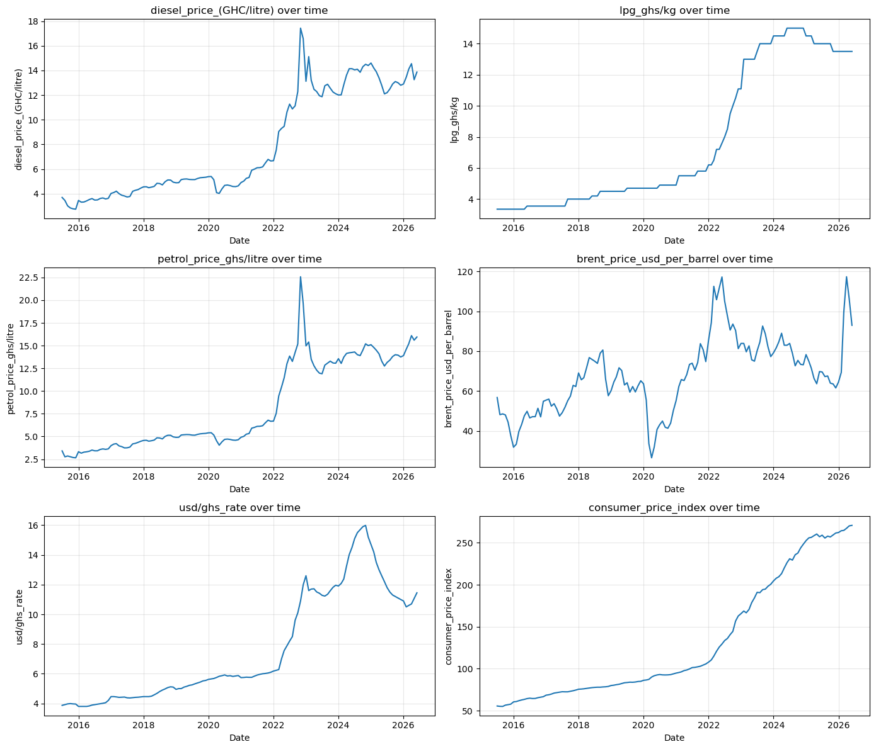
Figure 4.1

Figure 4.2: Distributions of the six analysis variables
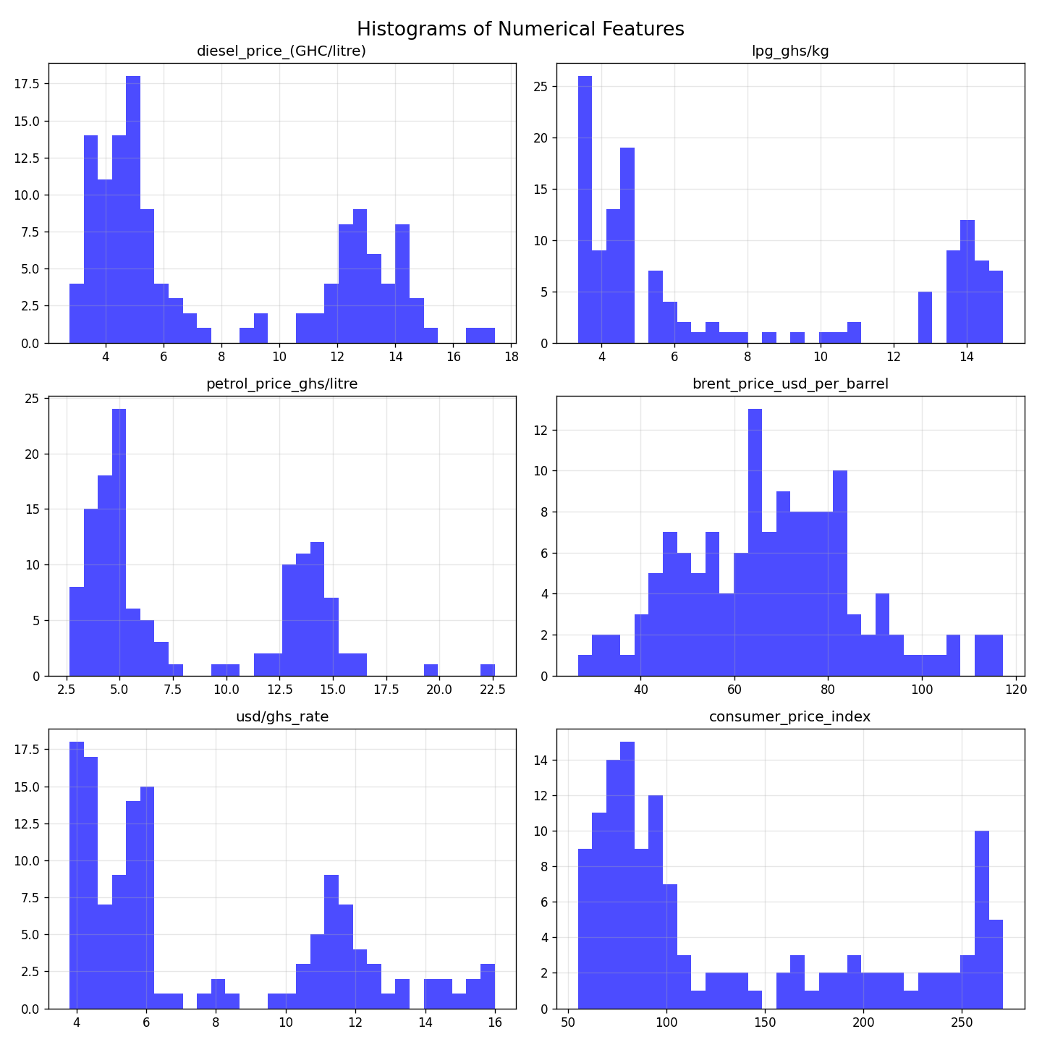
Figure 4.2
Every distribution is visibly bimodal or multimodal, with a low pre-2022 cluster and a higher post-2022 cluster — a distributional signature consistent with the structural break formally identified in Section 4.2. This pattern is clearest for diesel, LPG, petrol, and the exchange rate, and somewhat less pronounced for Brent crude, consistent with Brent’s more independent, internationally driven price dynamics.
Level correlations between the fuel-price series are high: diesel and petrol correlate at 0.9909, diesel and LPG at 0.9607, and petrol and LPG at 0.9274. Diesel is also strongly correlated with the exchange rate (0.9551) and CPI (0.9261), while Brent crude correlates more moderately with petrol (0.6883).

Figure 4.3: Correlation heatmap of the level series
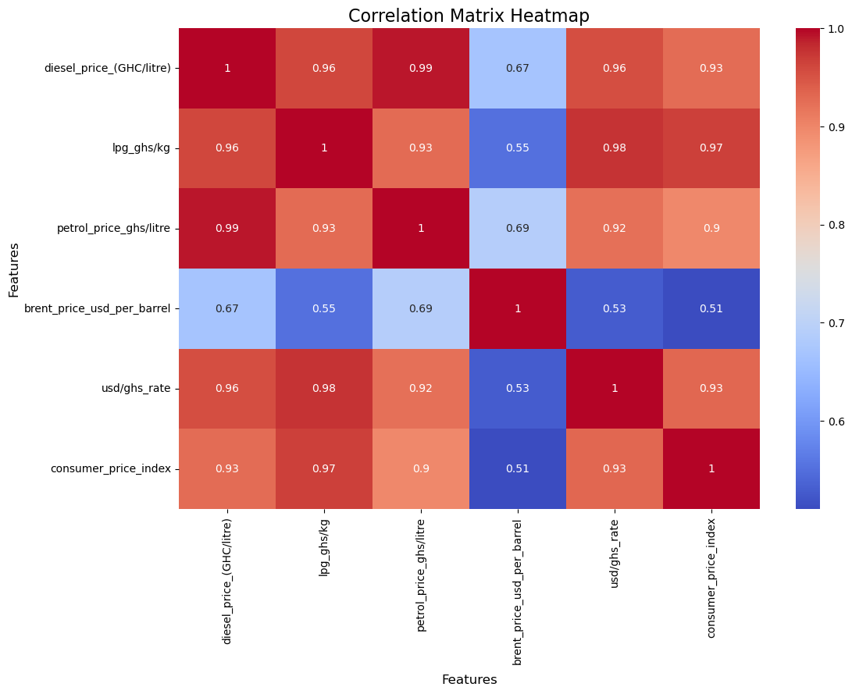
Figure 4.3
These high level correlations are consistent with shared long-run trends among the variables rather than evidence of a stable short-run relationship; because trending series can appear strongly correlated even without a genuine structural link (Granger & Newbold, 1974), the level relationships are re-examined using stationary transformations in the sections that follow.

4.2 Stationarity Test Results
Three complementary tests were applied to each of the six series: the Augmented Dickey-Fuller (ADF) test (null hypothesis: unit root), the KPSS test (null hypothesis: stationarity), and the Zivot-Andrews (ZA) test, which tests for a unit root while allowing for a single endogenously determined structural break (Zivot & Andrews, 1992).
Table 4.2: Stationarity test results at level
Series | ADF | KPSS | Zivot-Andrews | Estimated break
Diesel | Non-stationary | Non-stationary | Stationary with break | 2022-01
LPG | Non-stationary | Non-stationary | Stationary with break | 2022-03
Petrol | Non-stationary | Non-stationary | Stationary with break | 2022-02
Brent | Non-stationary | Non-stationary | Non-stationary | 2021-01
USD/GHS | Non-stationary | Non-stationary | Stationary with break | 2022-03
CPI | Non-stationary | Non-stationary | Non-stationary | 2022-02
ADF and KPSS agree that all six series are non-stationary at level. The Zivot-Andrews results add an important qualification: diesel, LPG, petrol, and the exchange rate are each classified as stationary once a single structural break is permitted, with the four estimated break dates clustering tightly around January–March 2022. This is strong, formally tested evidence corroborating the visual and narrative account of the 2022 fuel-price and currency crisis given in Chapter One. Brent crude and CPI remain non-stationary even allowing for a break; this is plausible, since Brent follows international commodity-market dynamics largely independent of the domestic Ghanaian shock, while CPI is a cumulative index that does not revert after a shock by construction.
Table 4.3: Stationarity after first differencing (d = 1)
Series | ADF | KPSS
Diesel | Stationary | Stationary
Petrol | Stationary | Stationary
Brent | Stationary | Stationary
USD/GHS | Stationary | Stationary
LPG | Non-stationary (p = 0.127) | Stationary
CPI | Non-stationary | Non-stationary
Diesel, petrol, Brent, and the exchange rate achieve stationarity after first differencing under both tests. LPG is borderline: KPSS supports stationarity while ADF does not reject the unit-root null at the 5% level (p = 0.127). Given that both tests agreed decisively that LPG was non-stationary at level, and following standard practice of treating KPSS as more informative in this near-unit-root region (Hyndman & Athanasopoulos, 2018), LPG is treated as adequately stationary at d = 1 for the ARIMA and ARIMAX workflows, with this ambiguity noted explicitly here rather than concealed. CPI remains non-stationary at d = 1 under both tests and requires second differencing (ADF p = 0.0087, KPSS p = 0.10 at d = 2).
Because the VAR model requires a common order of integration across all system variables, and CPI is part of that system, all six variables entering the VAR model — diesel, petrol, LPG, Brent, the exchange rate, and CPI — are second-differenced for consistency, even though most of them were already stationary at d = 1 individually. This is a standard and conservative choice: a series stationary at d = 1 remains stationary at d = 2, at the modest cost of slightly noisier differenced values. ARIMA and ARIMAX retain each series’ own correct individual order (d = 1 in all three cases).
The clustering of Zivot-Andrews break dates around early 2022 is treated as a substantive finding rather than a nuisance: it is referenced again in Sections 4.3 and 4.6 to explain patterns observed in the residual diagnostics of the fitted models.

4.3 ARIMA Model Results
Figure 4.4: ACF and PACF of the first-differenced diesel price series
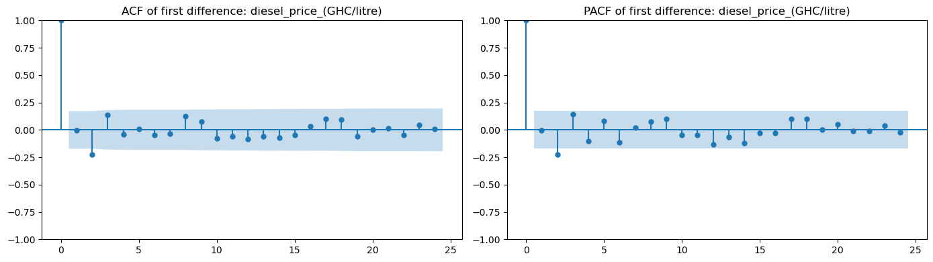
Figure 4.4
Figure 4.5: ACF and PACF of the first-differenced petrol price series
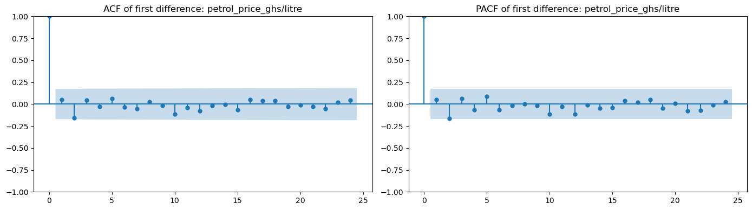
Figure 4.5
Figure 4.6: ACF and PACF of the first-differenced LPG price series
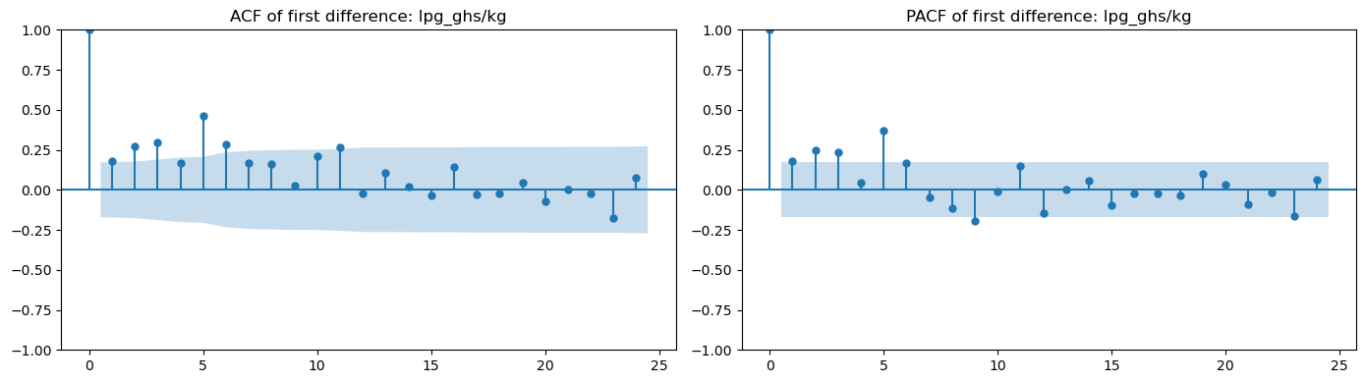
Figure 4.6
All three fuel series show a similar pattern: a sharp cutoff at low lags rather than gradual decay, consistent with a low-order ARMA process and supporting the AIC-based grid search conducted over p, q ∈ {0, 1, 2, 3} below.
Univariate ARIMA models were fitted to each fuel-price series using its own history only. The final six months of the sample (January–June 2026) were withheld as an out-of-sample test set, with the preceding 126 months (July 2015–December 2025) used for training and order selection. Candidate orders (p, 1, q) with p, q ∈ {0, 1, 2, 3} were compared using training-set AIC.
Table 4.4: ARIMA model results (six-month holdout)
Series | Selected order | MAE | RMSE | MAPE | Ljung-Box p (lag 10)
Diesel | (0, 1, 3) | 0.8652 | 1.0243 | 6.17% | 0.9699
Petrol | (0, 1, 3) | 1.4638 | 1.6534 | 9.38% | 0.9934
LPG | (2, 1, 2) | 0.1888 | 0.2293 | 1.40% | 0.0338
Figure 4.7: ARIMA(0,1,3) forecast against observed values, diesel price (six-month holdout)
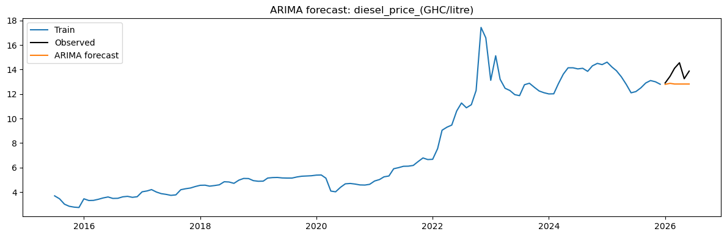
Figure 4.7
Figure 4.8: ARIMA(0,1,3) residual diagnostics, diesel price
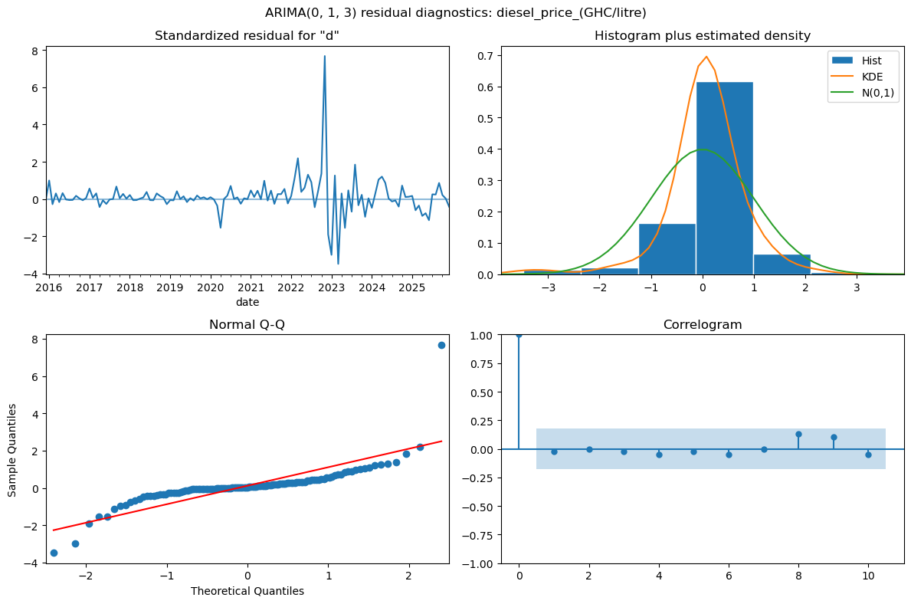
Figure 4.8
Diesel and petrol residuals show no evidence of remaining autocorrelation (Ljung-Box p > 0.9 in both cases), indicating that the fitted ARIMA structures adequately capture the short-run dependence in these series. However, the residual diagnostics reveal a distributional issue not captured by the Ljung-Box test alone: a single large standardized diesel residual (exceeding 7) around late 2022, corresponding to the same fuel-price spike examined in Sections 4.1 and 4.2, visibly departs from the reference line in the Q-Q plot and produces a right-skewed, heavy-tailed residual histogram relative to the fitted normal density. This pattern — adequate autocorrelation structure alongside non-normal, outlier-driven residuals — recurs across all three fuels and both conditional models (ARIMA and ARIMAX, Section 4.4), and is attributed throughout to the 2021–2022 structural shock rather than to model misspecification. Point forecasts remain valid, but associated prediction intervals should be treated with caution, since they are constructed under a normality assumption this residual distribution does not fully satisfy.
Figure 4.9: ARIMA forecast against observed values, petrol price (six-month holdout)
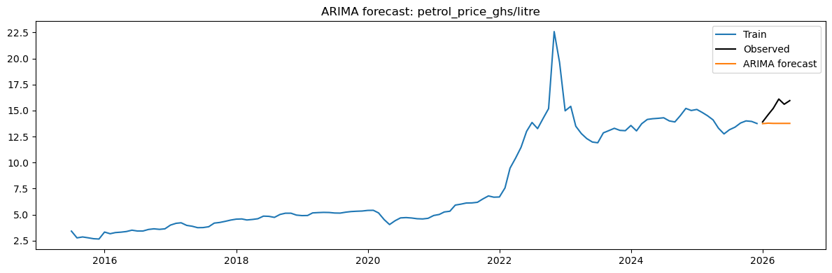
Figure 4.9
Figure 4.10: ARIMA(0,1,3) residual diagnostics, petrol price
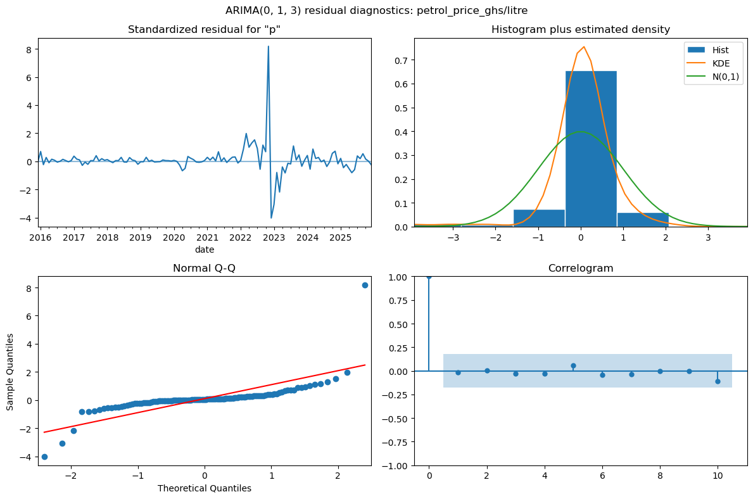
Figure 4.10
Petrol’s residual diagnostics closely mirror diesel’s: a single dominant standardized residual near 8 in late 2022, with the same right-skewed, heavy-tailed departure from normality in the Q-Q plot and histogram. Petrol has the largest absolute forecast errors of the three series (Table 4.4), though this partly reflects its wider price range and the same extreme 2022 spike (petrol’s series maximum of GHS 22.58/litre is markedly above its typical range).
Figure 4.11: ARIMA(2,1,2) forecast against observed values, LPG price (six-month holdout)
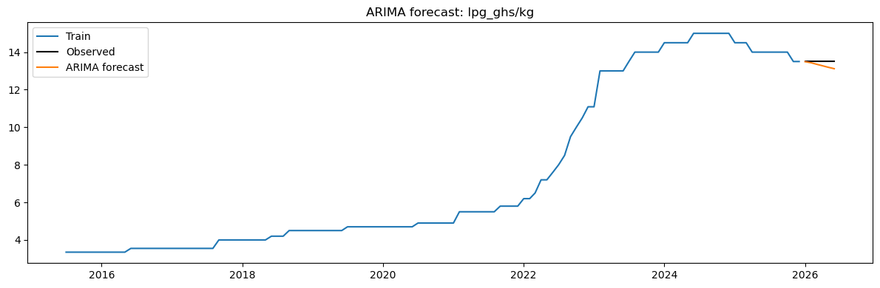
Figure 4.11
Figure 4.12: ARIMA(2,1,2) residual diagnostics, LPG price
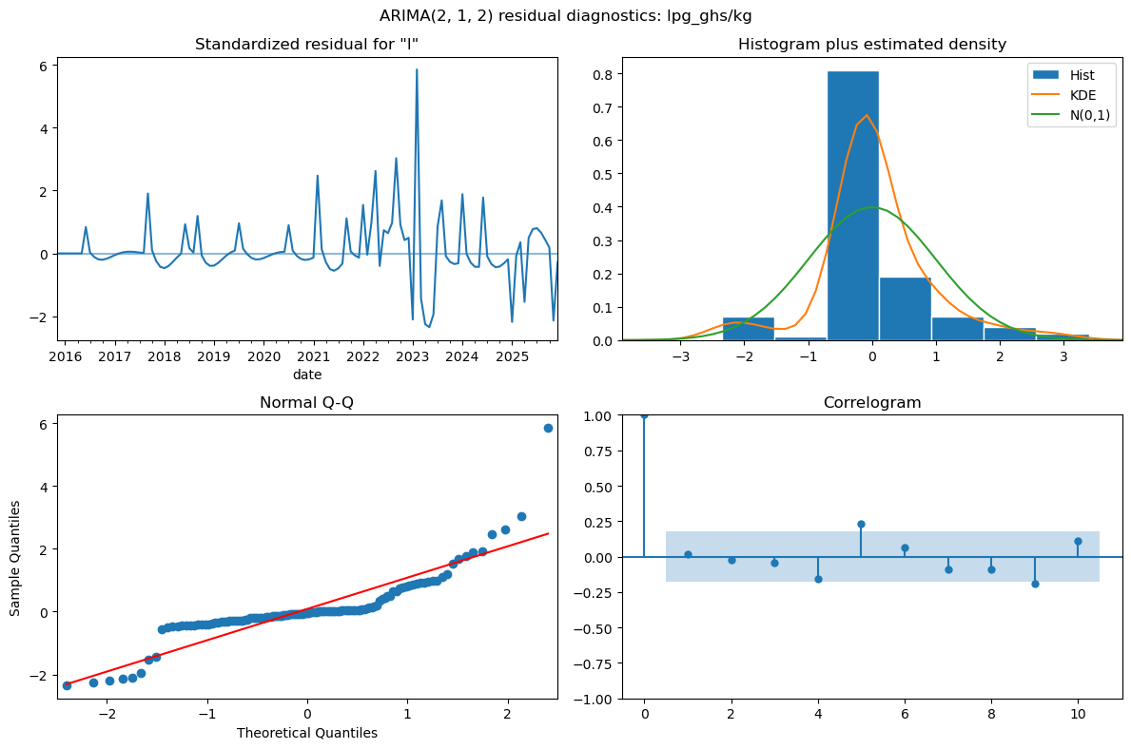
Figure 4.12
LPG’s residual pattern differs qualitatively from diesel and petrol: rather than one dominant late-2022 outlier, the standardized residuals show several recurring moderate spikes spread across the sample (2017, 2019, 2021, 2023), and the correlogram shows a visible spike at lag 5 that sits outside the 95% confidence band — the visual counterpart of the Ljung-Box test’s rejection (p = 0.034) reported in Table 4.4. This indicates that LPG’s ARIMA(2,1,2) model, unlike diesel’s and petrol’s, is leaving a genuine, recurring autocorrelation structure unexplained rather than being driven by a single 2022 shock. This is addressed directly in Section 4.4, where the addition of external regressors is shown to resolve the issue.

4.4 ARIMAX Model Results
The ARIMAX specification extends each ARIMA model with Brent crude oil prices and the USD/GHS exchange rate as exogenous regressors, motivated by the theoretical channel through which international oil prices and currency depreciation feed into domestic pump prices. The same training/test split and order-search procedure as Section 4.3 were used.
Table 4.5: ARIMAX model results (six-month holdout)
Series | Selected order | MAE | RMSE | MAPE | Ljung-Box p (lag 10)
Diesel | (0, 1, 3) | 0.4769 | 0.5526 | 3.49% | 0.7909
Petrol | (0, 1, 3) | 0.7162 | 0.7801 | 4.65% | 0.9618
LPG | (1, 1, 3) | 0.1136 | 0.1349 | 0.84% | 0.4731
ARIMAX reduces both MAE and RMSE relative to ARIMA for all three fuel series in the six-month holdout, with the largest proportional improvement for diesel and petrol (MAE roughly halved in both cases). The residual autocorrelation problem identified in the LPG ARIMA model is resolved: the LPG ARIMAX Ljung-Box p-value rises to 0.473, indicating no remaining serial dependence once Brent and the exchange rate are included. This result supports the study’s third objective — that external, economically motivated predictors carry information beyond the fuel price’s own history.
This result must be interpreted conditionally. The reported forecasts supply the model with the actual observed Brent and exchange-rate values for the test period; in an operational forecasting setting, these external variables would themselves need to be forecast or otherwise estimated, and any uncertainty in those inputs would propagate into the fuel-price forecast. The six-month holdout result therefore demonstrates the information content of Brent and the exchange rate for fuel-price forecasting, rather than the accuracy achievable in a fully unconditional, real-time forecasting exercise.
Figure 4.13: ARIMAX(0,1,3) forecast against observed values, diesel price (six-month holdout)
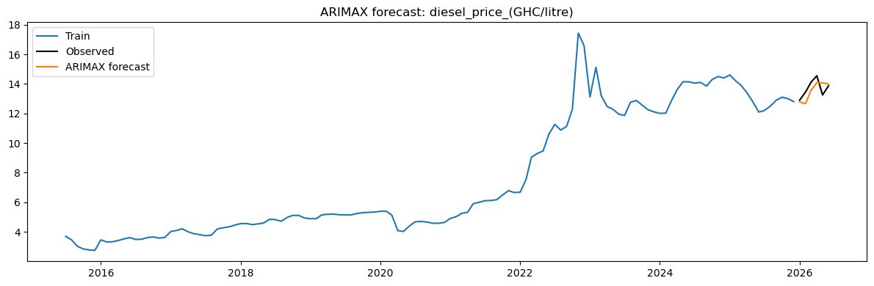
Figure 4.13
Figure 4.14: ARIMAX(0,1,3) residual diagnostics, diesel price
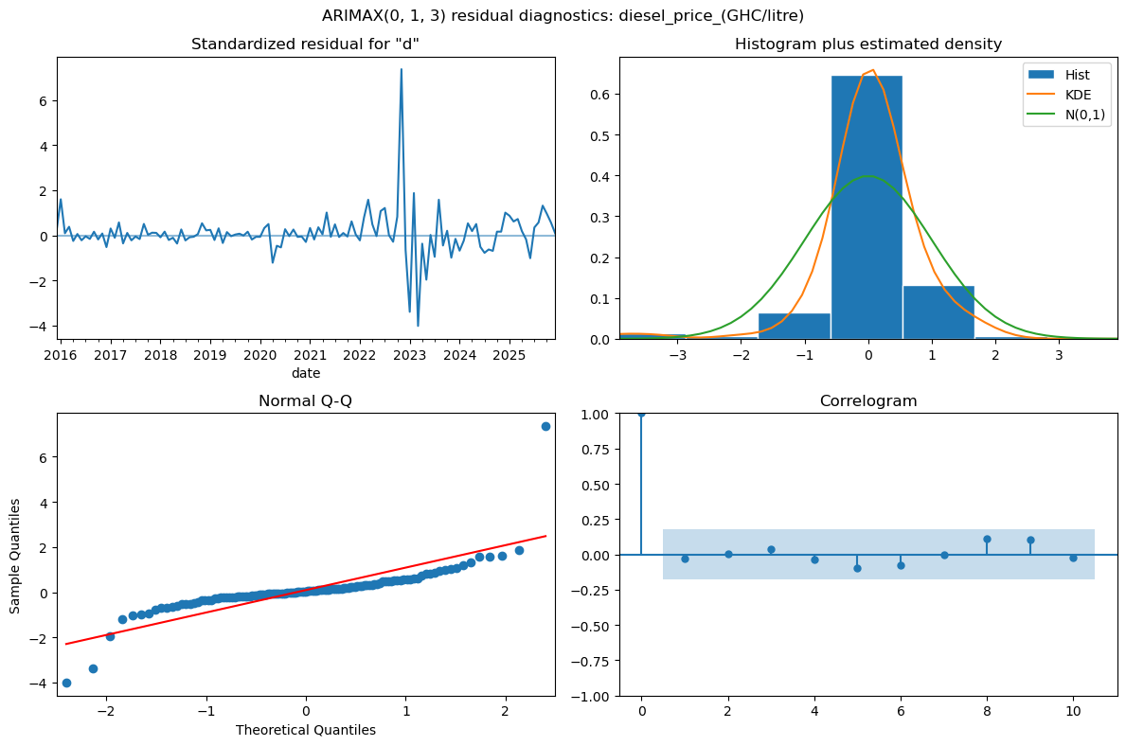
Figure 4.14
The same outlier-driven non-normality observed in the ARIMA residuals (Figure 4.8) persists in the ARIMAX diesel residuals, with the standardized residual for late 2022 still exceeding 7 despite the inclusion of Brent and the exchange rate as regressors. This confirms that Brent and the exchange rate improve point-forecast accuracy without fully absorbing the effect of the 2022 shock on the residual distribution — consistent with the shock being a domestically specific event (the currency depreciation crisis, Section 4.2) only partially explained by these two external variables.
Figure 4.15: ARIMAX forecast against observed values, petrol price (six-month holdout)
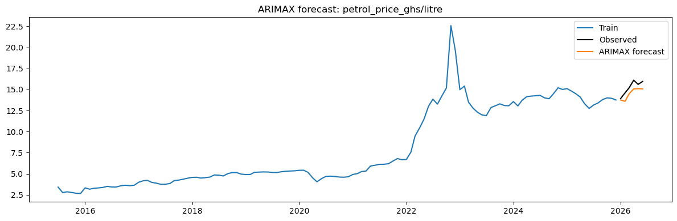
Figure 4.15
Figure 4.16: ARIMAX(0,1,3) residual diagnostics, petrol price
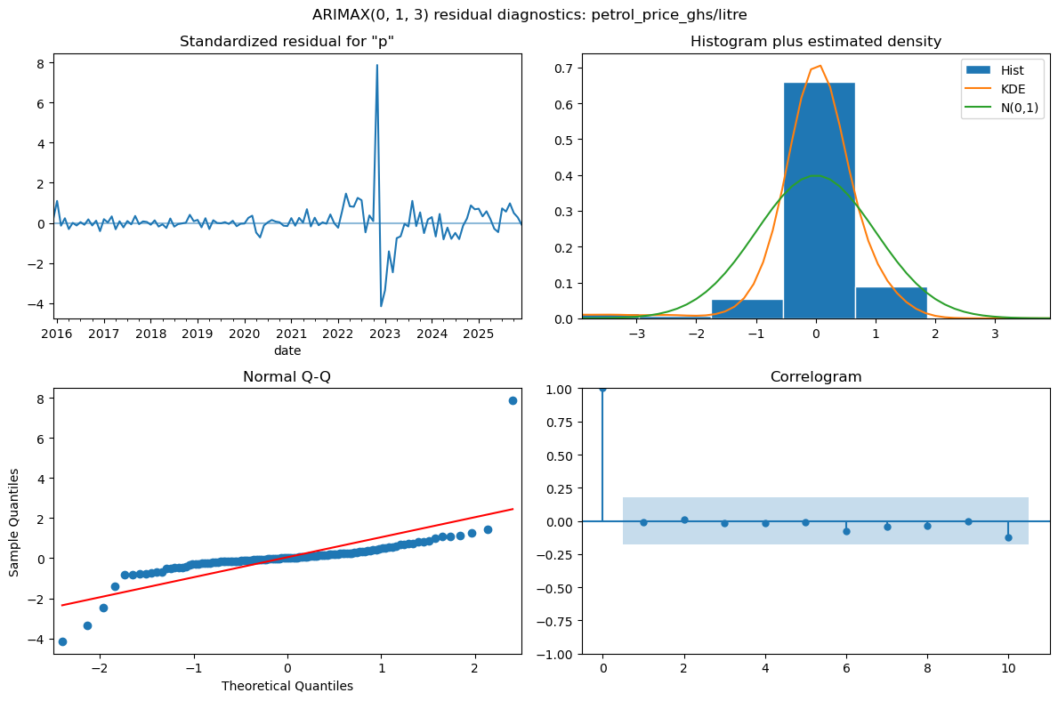
Figure 4.16
Petrol’s ARIMAX residuals show the same persistent late-2022 outlier and heavy-tailed departure from normality as diesel’s, essentially unchanged from the ARIMA case in magnitude.
Figure 4.17: ARIMAX(1,1,3) forecast against observed values, LPG price (six-month holdout)
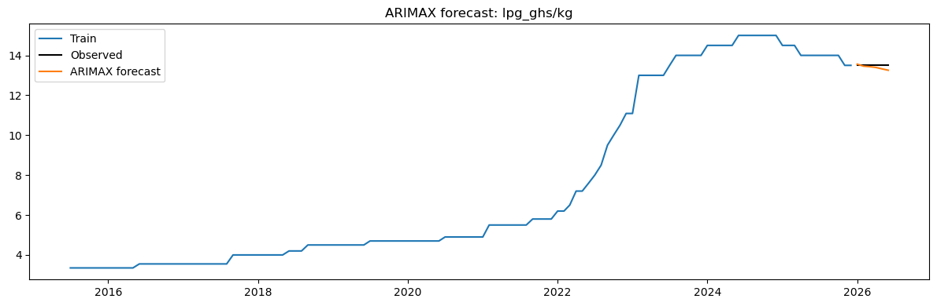
Figure 4.17

Figure 4.18: ARIMAX(1,1,3) residual diagnostics, LPG price
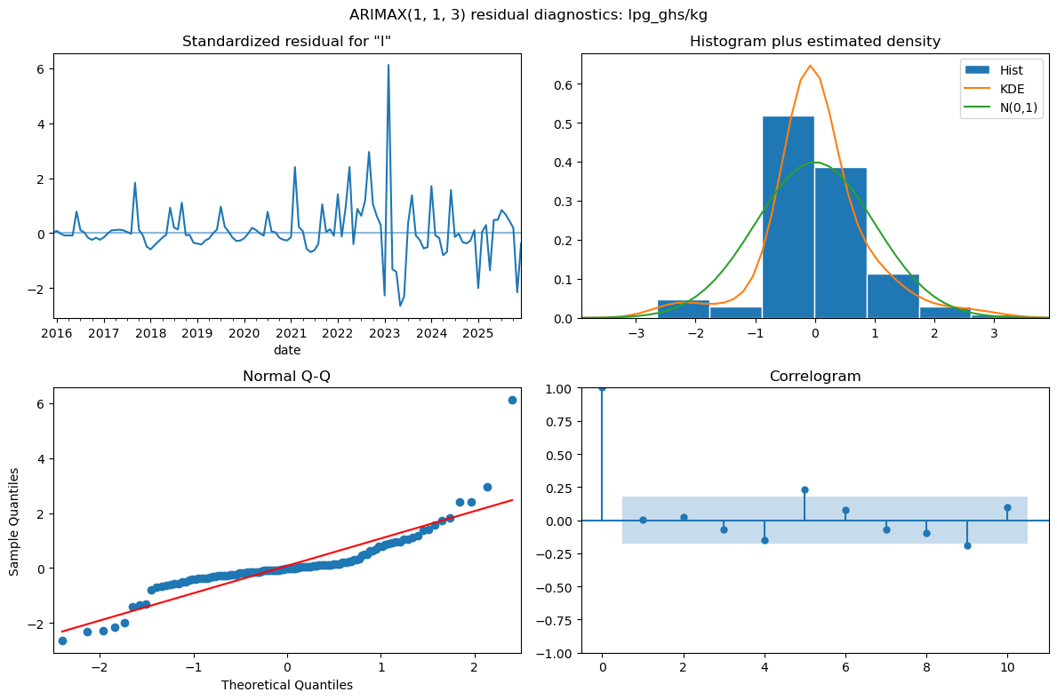
Figure 4.18
LPG’s ARIMAX correlogram still shows a lag-5 spike of similar visual magnitude to the ARIMA case (Figure 4.12), despite the joint Ljung-Box test passing comfortably (p = 0.473 versus 0.034). This is not a contradiction: Ljung-Box at lag 10 is a joint test summed across all ten lags, so a single borderline lag does not necessarily drive the overall statistic below significance, particularly once the additional regressors and MA terms absorb some of the surrounding structure. The practical reading is that ARIMAX meaningfully improves LPG’s joint autocorrelation profile and forecast accuracy, but a residual, lag-5-specific structure is still visually present and worth acknowledging rather than treating the passed Ljung-Box test as a complete resolution.

4.5 Rolling-Origin Forecast Evaluation
To assess forecast accuracy more robustly than a single six-month holdout allows, a rolling-origin evaluation was conducted. Starting from an initial training window of 96 months, ARIMA, ARIMAX, and VAR orders were identified once from this initial window and then re-fitted (using the fixed order) at each of 31 successive forecast origins, producing forecasts at horizons of one to six months from each origin. This design follows standard rolling-origin evaluation practice (Hyndman & Athanasopoulos, 2018) while keeping model orders fixed across origins for computational tractability — a simplification made explicit here rather than left implicit. The orders identified from this shorter 96-month window (ARIMA: diesel (2,1,2), petrol (0,1,3), LPG (3,1,3); ARIMAX: diesel (1,1,2), petrol (0,1,3), LPG (3,1,1); VAR lag 5) differ from those used in the main six-month holdout analysis above (Sections 4.3–4.4, 4.6), which were identified from the larger 126-month training window. This is an expected consequence of order selection depending on the sample used, and is noted here for transparency rather than treated as an inconsistency.
Errors were summarised using MAE, RMSE, and MAPE at each horizon, and Diebold-Mariano (Diebold & Mariano, 1995) tests were used to assess whether differences in squared-error loss between model pairs were statistically distinguishable from sampling variation, using a HAC-adjusted variance with a bandwidth equal to (horizon − 1) lags, following the original Diebold-Mariano recommendation for h-step-ahead forecast errors.
Table 4.6: Cumulative rolling-origin accuracy at selected horizons, all three fuels
Series | Model | Horizon 1 MAE | Horizon 3 MAE | Horizon 6 MAE
Diesel | ARIMA | 0.3868 | 0.5550 | 0.7422
Diesel | ARIMAX | 0.5235 | 0.7750 | 1.0302
Diesel | VAR | 0.9300 | 1.3256 | 1.7789
Petrol | ARIMA | 0.3347 | 0.5133 | 0.7313
Petrol | ARIMAX | 0.5180 | 0.8686 | 1.2864
Petrol | VAR | 1.3123 | 1.8200 | 2.4953
LPG | ARIMA | 0.1853 | 0.3041 | 0.4312
LPG | ARIMAX | 0.2073 | 0.3620 | 0.6157
LPG | VAR | 0.2530 | 0.3497 | 0.5504
Figure 4.19: Rolling-origin MAE by forecast horizon, 31 forecast origins
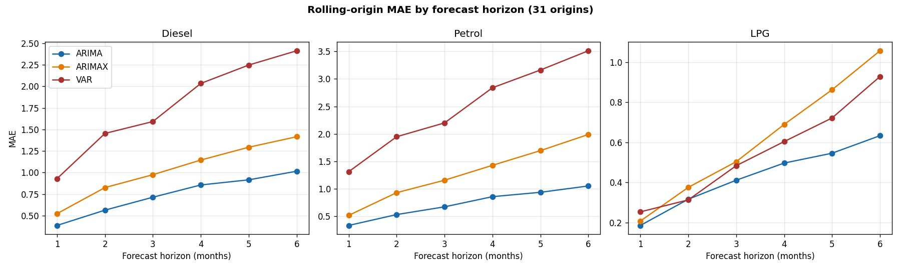
Figure 4.19
Figure 4.19 and Table 4.6 together make the rolling-origin pattern clear: ARIMA’s error sits consistently below both ARIMAX and VAR at every horizon for diesel and petrol, with the gap widening as the horizon extends to six months. LPG shows a different, more compressed pattern: ARIMA and ARIMAX track closely at short horizons before diverging after horizon 3, and VAR — unlike its clearly worse performance for diesel and petrol — is competitive with, or in the case of horizon 6, better than ARIMAX for LPG (0.5504 versus 0.6157 MAE).

Table 4.7: Diebold-Mariano test results at the one-month cumulative horizon, all three fuels
Series | Comparison | DM statistic | p-value | Significant (5%)
Diesel | ARIMA vs. ARIMAX | −0.93 | 0.353 | No
Diesel | ARIMA vs. VAR | −2.25 | 0.024 | Yes
Diesel | ARIMAX vs. VAR | −1.92 | 0.055 | No
Petrol | ARIMA vs. ARIMAX | −2.50 | 0.012 | Yes
Petrol | ARIMA vs. VAR | −2.70 | 0.007 | Yes
Petrol | ARIMAX vs. VAR | −2.46 | 0.014 | Yes
LPG | ARIMA vs. ARIMAX | −0.35 | 0.725 | No
LPG | ARIMA vs. VAR | −1.33 | 0.184 | No
LPG | ARIMAX vs. VAR | −1.07 | 0.283 | No
At the one-month horizon, ARIMA significantly outperforms VAR for diesel, and significantly outperforms both ARIMAX and VAR for petrol. LPG tells a markedly different story: none of the three pairwise comparisons reach significance at the 5% level. This means that, despite the numerical MAE differences visible in Table 4.6, the rolling-origin evidence does not support a statistically confident ranking of the three models for LPG at this horizon — the models are, in a formal statistical sense, indistinguishable for LPG here, unlike the clear ARIMA advantage established for diesel and petrol. This distinction matters directly for Objective 4: model superiority is not uniform across fuels, and LPG in particular does not support a strong “ARIMA is best” claim the way diesel and petrol do. The full set of pairwise comparisons across all horizons and series is reported in Notebook 06.
This result appears, at first glance, to contradict the six-month single-holdout finding in Section 4.4, where ARIMAX outperformed ARIMA. The two results are not actually in conflict: they answer different questions. The single holdout in Sections 4.3–4.4 reflects performance in one specific final period (January–June 2026); the rolling-origin evaluation summarises performance repeatedly, averaged across 31 different forecast origins spanning a much longer and more varied period. The rolling result indicates that ARIMAX’s advantage over ARIMA in the final six-month window is not consistently replicated across the full evaluation history, whereas the single-holdout result shows that, specifically for the most recent period, adding Brent and the exchange rate did help. Both findings are retained and reported together, as each carries different practical implications: the rolling result speaks to average historical reliability, while the holdout result speaks to recent, current-regime performance.

4.6 VAR Model Results
The VAR model treats the three fuel prices, Brent crude, the exchange rate, and CPI as a single interdependent six-variable system. Because CPI remains non-stationary after first differencing (Section 4.2), the complete system was estimated in second differences, and forecasts were integrated twice to return to the original price levels. Candidate lag lengths from one to six months were evaluated, restricted to lags producing a stable VAR system, with the lowest-AIC stable candidate selected.

Table 4.8: VAR lag-order selection
Lag | AIC | BIC
2 | −4.857 | −3.026 (BIC-preferred)
6 | −5.800 (AIC-preferred) | −0.588
AIC and BIC disagree: AIC favours the higher-order lag-6 specification, while BIC, which penalises additional parameters more heavily, favours the more parsimonious lag 2. Given the modest effective sample size (approximately 118–122 usable observations for a six-variable system after second differencing), this disagreement raises a legitimate concern about overparameterization at lag 6, where each of the six equations estimates 37 parameters (an observations-to-parameters ratio of roughly 3.2), compared with 13 parameters per equation at lag 2 (a ratio of roughly 9.4).
To resolve this, both specifications were fitted and compared directly on residual diagnostics and six-month holdout forecast accuracy.
Table 4.9: Lag-2 versus lag-6 robustness comparison
Lag | Obs./  parameter | Whiteness stat | Normality stat | Diesel MAE | Petrol MAE | LPG MAE
2 | 9.38 | 473.06 (p < 0.001) | 861.07 (p < 0.001) | 1.9805 | 2.8416 | 0.5031
6 | 3.19 | 277.51 (p < 0.001) | 251.34 (p < 0.001) | 2.0456 | 2.2219 | 0.2198
Contrary to the initial overparameterization concern, reducing the lag order to 2 did not improve residual behaviour — normality was in fact substantially more strongly rejected at lag 2 (statistic 861 versus 251) — and produced materially weaker six-month forecast accuracy for petrol and LPG. This pattern suggests that the residual non-normality present in the VAR system at both lag lengths is driven primarily by the 2021–2022 structural shock identified via the Zivot-Andrews test (Section 4.2), which a lower-order VAR captures even less completely than a higher-order one, rather than being a symptom of lag-6 overparameterization. On the combined weight of AIC-optimality, superior forecast accuracy, and the finding that parsimony does not resolve the residual issue, lag 6 is retained as the final VAR specification.
Figure 4.20: VAR (second-difference, lag 6) forecast against observed values, diesel price (six-month holdout)
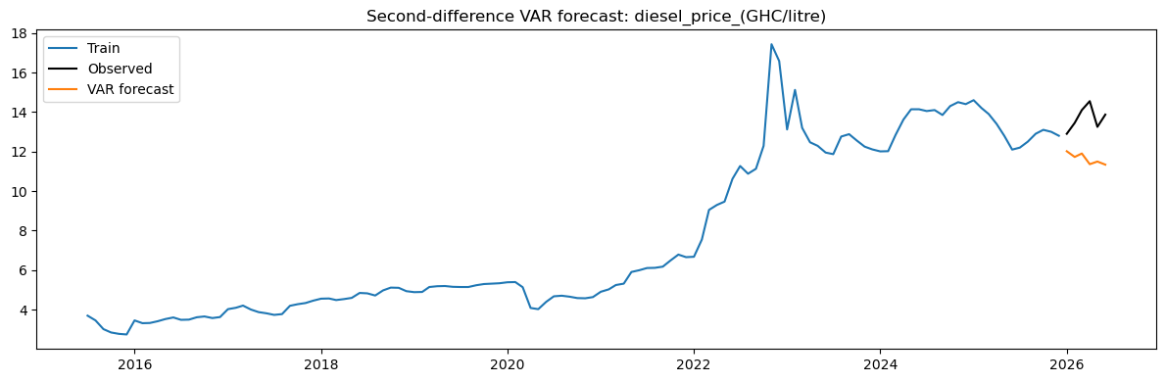
Figure 4.20
Figure 4.20 shows the VAR forecast visibly diverging from the observed post-holdout rebound in diesel prices — the model’s forecast trends downward through the test period while actual prices rise, which is consistent with VAR’s larger MAE and RMSE relative to ARIMA and ARIMAX reported below.
Figure 4.21: VAR(6) equation residual diagnostics, diesel price
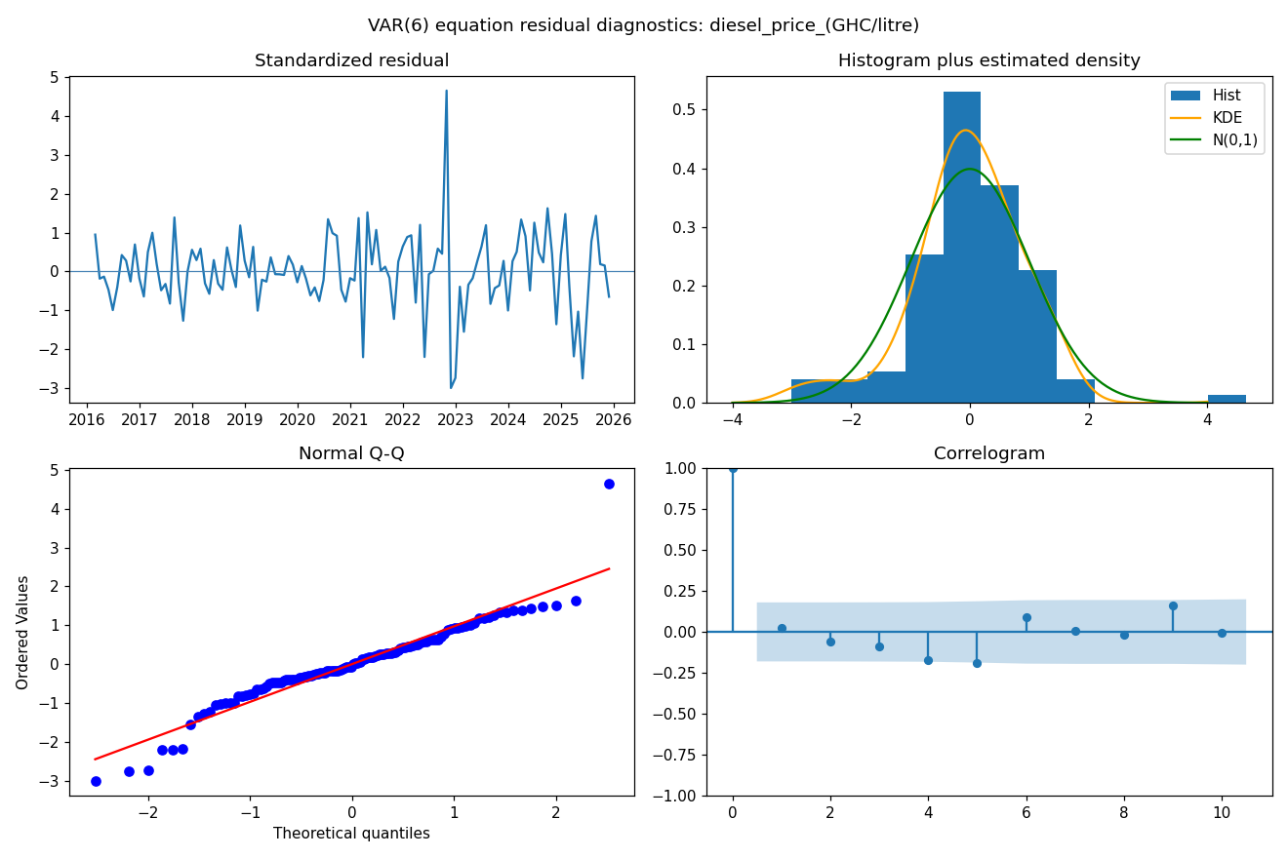
Figure 4.21
Because the VAR notebook reports only joint, system-wide whiteness and normality tests (below), per-equation residual diagnostics were generated separately here for direct comparability with the ARIMA and ARIMAX diagnostics above. Diesel’s VAR-equation residuals show the now-familiar late-2022 outlier (standardized residual approaching 5), with a correspondingly heavy-tailed departure in the Q-Q plot, though somewhat less extreme in magnitude than the univariate ARIMA/ARIMAX diesel residuals.
Figure 4.22: VAR forecast against observed values, petrol price (six-month holdout)
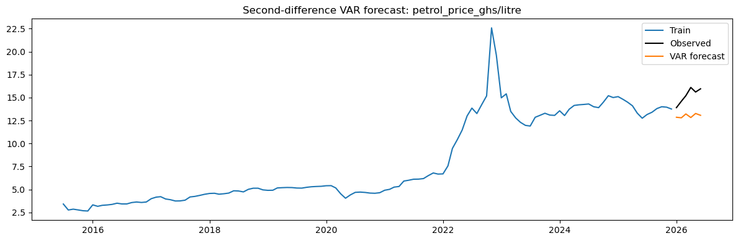
Figure 4.22
Figure 4.23: VAR(6) equation residual diagnostics, petrol price
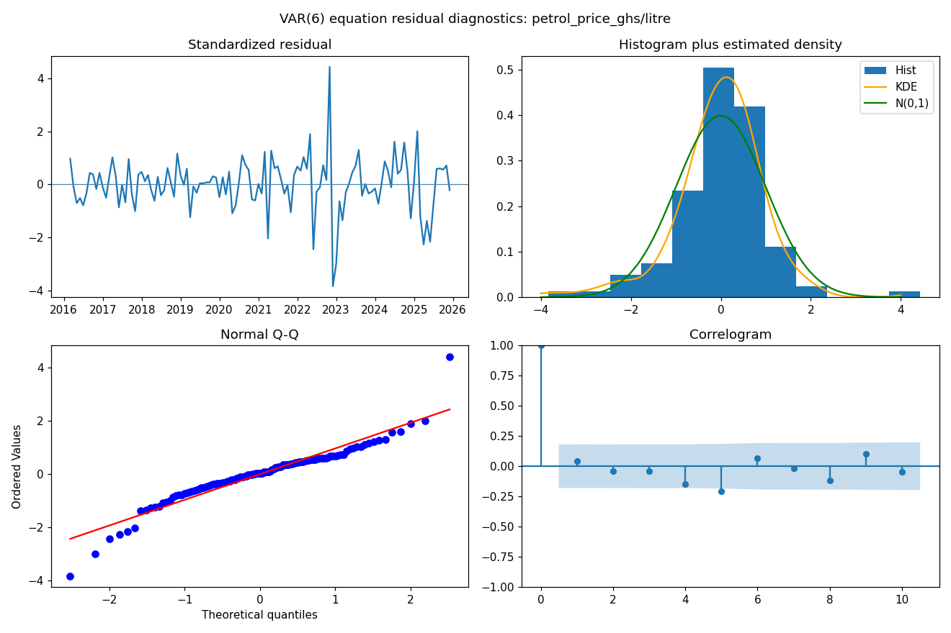
Figure 4.23
Figure 4.24: VAR forecast against observed values, LPG price (six-month holdout)
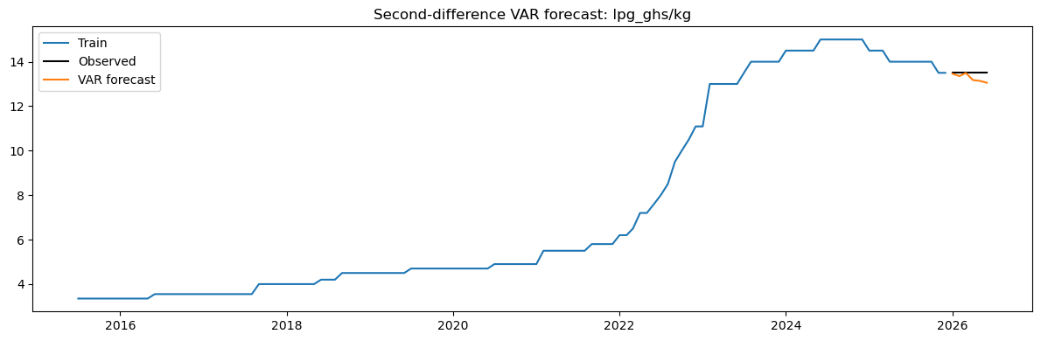
Figure 4.24

Figure 4.25: VAR(6) equation residual diagnostics, LPG price
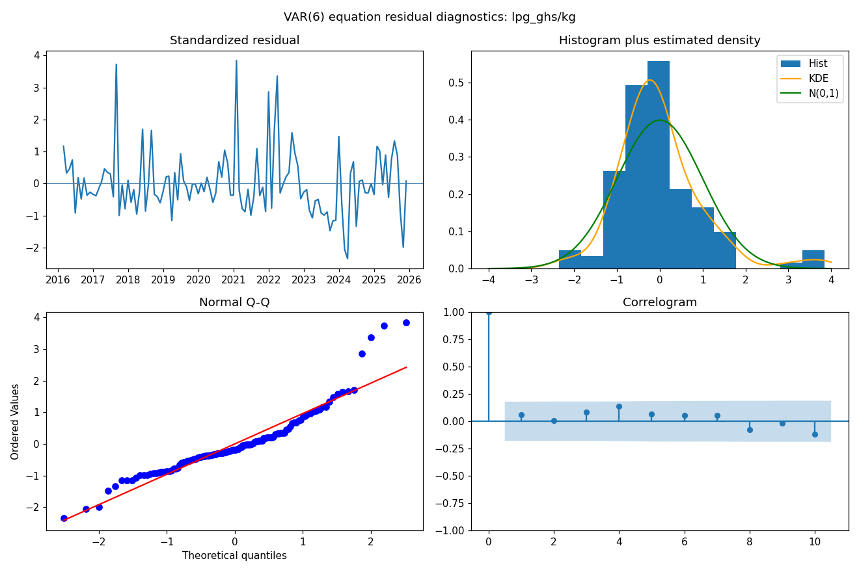
Figure 4.25
The petrol and LPG VAR forecasts follow the same downward-drifting pattern seen for diesel, missing the post-holdout rebound in all three series. LPG’s equation residuals again depart from the diesel/petrol pattern in the same way observed for ARIMA and ARIMAX: rather than one dominant late-2022 spike, LPG shows several recurring moderate departures (2017, 2021, 2024) and a comparatively clean correlogram, with no individual lag clearly outside the confidence band — consistent with LPG’s distinct, less shock-concentrated residual behaviour across all three model families.
Table 4.10: VAR forecast results (lag 6, six-month holdout)
Series | MAE | RMSE | MAPE
Diesel | 2.0456 | 2.1683 | 14.77%
Petrol | 2.2219 | 2.3378 | 14.39%
LPG | 0.2198 | 0.2757 | 1.63%
VAR produces larger errors than both ARIMA and ARIMAX for diesel and petrol in the six-month holdout, and is not the preferred point-forecasting model for these series. Its value lies elsewhere: in its capacity to characterise joint dynamics among the system variables, which ARIMA and ARIMAX, as univariate and conditionally univariate models respectively, cannot address.
Residual diagnostics. The multivariate residual whiteness test rejects the null of no remaining autocorrelation (test statistic 277.51 against a critical value of 173.00, p < 0.001), and the multivariate normality test likewise rejects (test statistic 251.34 against a critical value of 21.03, p < 0.001). As established above, these violations persist even at the more parsimonious lag 2, supporting the interpretation that they reflect the 2021–2022 structural shock rather than a correctable specification error. The VAR system should accordingly be read as an informative benchmark for system-level dynamics rather than as a residually adequate forecasting model in its own right.
Granger causality. Pairwise Granger-causality tests (Table 4.11) examine whether the lagged values of each system variable help predict each fuel-price series, conditional on the fitted lag-6 VAR.
Table 4.11: Pairwise Granger-causality results (causing → target)
Causing variable | Target variable | F-statistic | p-value | Significant (5%)
USD/GHS rate | Diesel | 6.98 | < 0.001 | Yes
LPG | Diesel | 3.96 | 0.001 | Yes
Petrol | Diesel | 2.29 | 0.034 | Yes
Brent crude | Diesel | 2.22 | 0.040 | Yes
CPI | Diesel | 0.79 | 0.574 | No
Petrol | LPG | 5.73 | < 0.001 | Yes
USD/GHS rate | LPG | 4.14 | < 0.001 | Yes
Diesel | LPG | 3.13 | 0.005 | Yes
CPI | LPG | 1.24 | 0.286 | No
Brent crude | LPG | 0.52 | 0.792 | No
USD/GHS rate | Petrol | 6.88 | < 0.001 | Yes
LPG | Petrol | 2.95 | 0.008 | Yes
Diesel | Petrol | 1.81 | 0.096 | No
Brent crude | Petrol | 1.32 | 0.247 | No
CPI | Petrol | 0.44 | 0.851 | No
The exchange rate Granger-causes all three fuel prices at the 5% level, and each fuel price Granger-causes the others, consistent with the strong level correlations reported in Section 4.1 and with a common exchange-rate transmission channel. Brent crude Granger-causes diesel but not LPG or petrol, and CPI does not Granger-cause any of the three fuel prices at the 5% level. These results should be read as statements about predictive content within the fitted VAR system, not as claims of structural causal mechanisms (Granger, 1969).
Impulse responses and variance decomposition. Impulse-response functions (12-step horizon, Monte Carlo error bands, 500 replications) and forecast-error variance decomposition (6-step horizon) were also produced (Notebook 07) to characterise the estimated dynamic response of each fuel price to shocks in Brent, the exchange rate, and CPI, and the proportion of each fuel price’s six-month forecast-error variance attributable to each system variable.

Figure 4.26: Impulse responses of fuel prices to Brent, exchange-rate, and CPI shocks
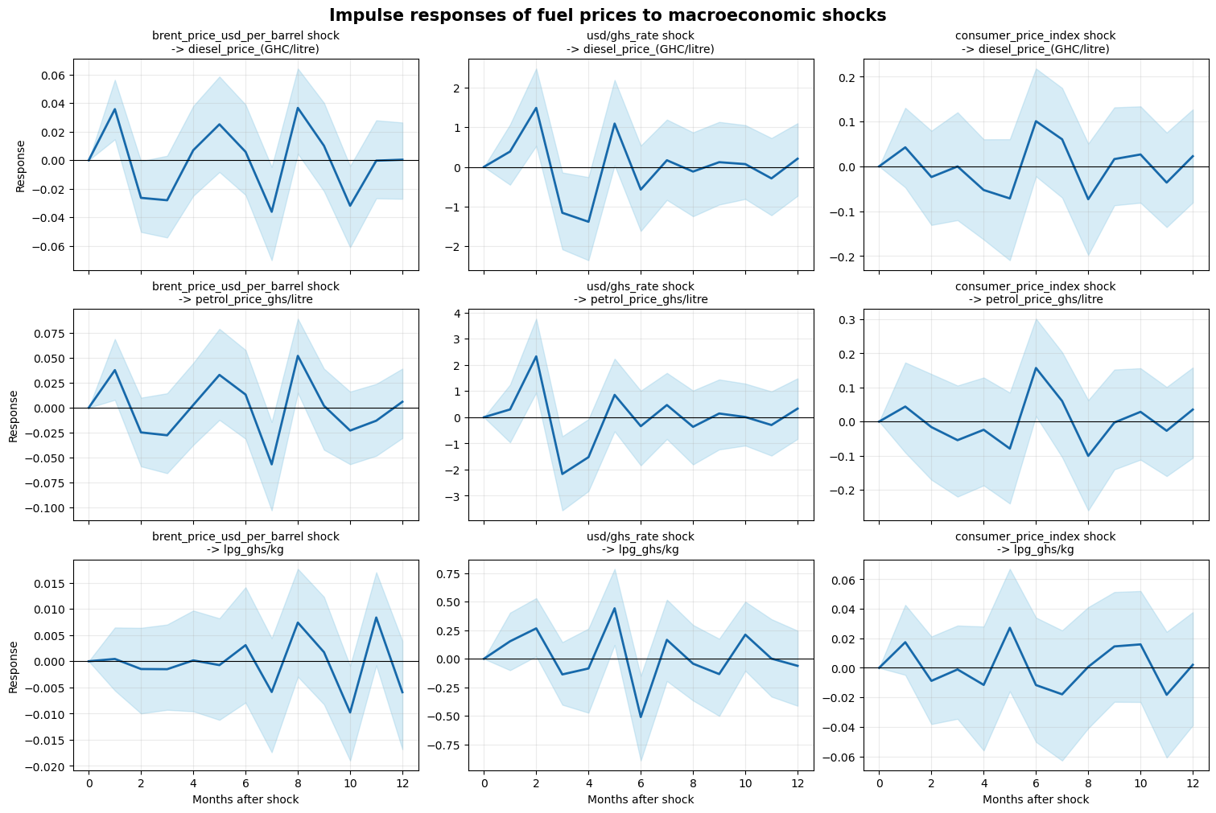
Figure 4.26
The impulse-response diagrams show diesel and petrol responding positively and with visible oscillation to both Brent and exchange-rate shocks, with the exchange-rate response noticeably larger in magnitude than the Brent response for both fuels — consistent with the stronger Granger-causality result for the exchange rate reported in Table 4.11. LPG’s responses to all three shocks are smaller in magnitude and less clearly distinguishable from zero, given its wider confidence bands.
Figure 4.27: Six-month forecast-error variance decomposition
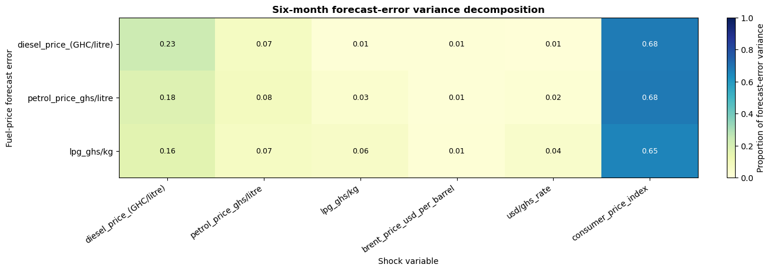
Figure 4.27
The variance decomposition produces a notable result: CPI accounts for the largest share of six-month forecast-error variance for all three fuel prices — 68% for diesel, 68% for petrol, and 65% for LPG — substantially exceeding each fuel’s own shock (23%, 18%, and 16% respectively) and far exceeding the direct contributions of Brent crude and the exchange rate (each 8% or less across all three fuels). This is a striking finding given that CPI did not Granger-cause any of the three fuel prices in Table 4.11’s pairwise tests. The two results are not contradictory: Granger causality in Table 4.11 tests only the direct, one-to-one predictive relationship between CPI and each fuel price, whereas the FEVD reflects CPI’s total contribution to forecast-error variance through the full dynamic system, including indirect transmission through the exchange rate and the other fuel prices, to which CPI is itself strongly correlated (Section 4.1) and dynamically linked at lag 6. This suggests CPI’s role in the system is best understood as a broad indicator of the same inflationary and currency pressures driving fuel prices, transmitted indirectly, rather than as a direct short-run predictor in its own right. This finding is presented as a descriptive, model-conditional output rather than independent causal evidence, consistent with the caveats already noted for the Granger-causality results above.

4.7 Discussion of Findings by Objective
Objective 1: Describe the statistical properties and trends. The exploratory analysis (Section 4.1) documents strong common upward movement across all six variables, with an unusually sharp episode in late 2022. The stationarity analysis (Section 4.2) confirms all six series are non-stationary in levels, and the Zivot-Andrews results formally corroborate that this episode constitutes a structural break for diesel, LPG, petrol, and the exchange rate.
Objective 2: Develop ARIMA, ARIMAX, and VAR models. All three model families were implemented and diagnosed. Differencing orders were established through the stationarity testing sequence, autoregressive and moving-average orders through ACF/PACF inspection and AIC comparison, and the VAR lag order through a combination of AIC/BIC comparison, stability checking, and the direct lag-2/lag-6 robustness comparison in Section 4.6.
Objective 3: Determine whether external shocks improve forecasts. The six-month holdout comparison (Sections 4.3–4.4) shows ARIMAX improving on ARIMA for all three fuel series, most substantially for diesel and petrol, and resolving the residual autocorrelation present in the LPG ARIMA model. This finding is qualified by the rolling-origin result (Section 4.5), which shows ARIMA outperforming ARIMAX across a longer, repeated evaluation history for diesel and petrol — indicating that the value of external regressors is real but not uniformly present across all forecasting conditions.
Objective 4: Compare accuracy across one- to six-month horizons. The rolling-origin procedure (Section 4.5) provides horizon-specific error metrics and Diebold-Mariano comparisons. Across the sampled horizons, ARIMA is the more consistently accurate univariate approach for diesel and petrol, with Diebold-Mariano tests confirming statistically significant advantages over VAR (and, for petrol, over ARIMAX too) at the one-month horizon. LPG is the exception: none of its pairwise model comparisons reach significance, so while ARIMA shows the lowest numerical error, the evidence does not support a statistically confident model ranking for this fuel.
Objective 5: Assess practical forecasting usefulness. All three model families can provide useful advance information about likely fuel-price movement, particularly at short horizons, but none should be treated as delivering certain point forecasts. ARIMAX’s six-month result is conditional on external-variable values that would themselves require forecasting in practice; the VAR system’s residual diagnostics indicate it is better suited to system-level analysis than to standalone point forecasting; and forecast uncertainty generally increases with horizon across all three approaches.

4.8 Summary of the Main Results
- The six fuel-price and macroeconomic series exhibit strong upward movement and high level correlation over the sample period, with an unusually sharp episode in late 2022.
- All six series are non-stationary in levels; Zivot-Andrews testing formally identifies a structural break clustering around January–March 2022 for diesel, LPG, petrol, and the exchange rate.
- ARIMA provides a credible univariate baseline; diesel and petrol residuals show no remaining autocorrelation, while LPG residuals retain some serial dependence (Ljung-Box p = 0.034).
- ARIMAX reduces six-month holdout forecast errors relative to ARIMA for all three fuel products and resolves the LPG residual autocorrelation issue.
- Rolling-origin evaluation across 31 forecast origins presents a more mixed picture, generally favouring ARIMA over ARIMAX for diesel and petrol.
- A direct lag-2 versus lag-6 robustness comparison shows that VAR’s residual non-normality is not resolved, and is in fact worsened, by reducing model complexity — supporting the interpretation that it reflects the 2021–2022 structural shock rather than overparameterization, and justifying the retention of the AIC-optimal lag-6 specification.
- VAR’s six-month point forecasts are less accurate than ARIMA or ARIMAX for diesel and petrol, but the model provides Granger-causality, impulse-response, and variance-decomposition evidence unavailable from the univariate approaches — most notably, that the exchange rate Granger-causes all three fuel prices.
- Forecast-error variance decomposition shows CPI contributing the largest share (65–68%) of six-month forecast-error variance for all three fuel prices — well above each fuel’s own shock or the direct contributions of Brent and the exchange rate — despite not directly Granger-causing any fuel price, indicating an indirect transmission channel through the system’s other variables rather than a direct predictive relationship.

4.9 Chapter Conclusion
This chapter has presented and interpreted the empirical results of the Ghana fuel-price forecasting study. Fuel prices over the study period are characterised by persistent trend behaviour, strong common movement with macroeconomic conditions, and a clearly identifiable structural disruption around 2021–2022. No single model dominates across every product and every forecast horizon: ARIMAX offers the strongest single-period result when Brent and exchange-rate information are available, ARIMA is the more consistently reliable univariate approach across repeated rolling evaluation, and VAR, while not the most accurate point forecaster, provides system-level insight — particularly the finding that the exchange rate Granger-causes all three fuel prices — unavailable from the other two approaches. The appropriate model therefore depends on whether the priority is univariate robustness, conditional forecasting accuracy, or the analysis of joint macroeconomic dynamics.
Chapter Five draws the final conclusions of the study, states its limitations, and provides recommendations for policymakers, consumers, analysts, and future researchers.

REFERENCES
Addae, E., & Ackah, I. (2017). Inflation dynamics in pre and post deregulation era in Ghana: Do petroleum prices have any influence? MPRA Paper 77496. University Library of Munich. https://mpra.ub.uni-muenchen.de/77496/
Alom, F., Ward, B. D., & Hu, B. (2013). Macroeconomic effects of world oil and food price shocks in Asia and Pacific economies: Application of SVAR models. OPEC Energy Review, 37(3), 327–372. https://doi.org/10.1111/opec.12015
Bank of Ghana. (2023). Annual report 2022. Bank of Ghana. https://www.bog.gov.gh/wp-content/uploads/2023/07/Annual-Report-2022.pdf
Baumeister, C., & Kilian, L. (2014). What central bankers need to know about forecasting oil prices. International Economic Review, 55(3), 869–889. https://doi.org/10.1111/iere.12074
Bawa, S., Abdullahi, I. S., & Ibrahim, A. (2016). Analysis of inflation dynamics in Nigeria (1981–2015). CBN Journal of Applied Statistics, 7(1b), 255–276. https://dc.cbn.gov.ng/jas/vol7/iss1/12
Box, G. E. P., Jenkins, G. M., Reinsel, G. C., & Ljung, G. M. (2015). Time series analysis: Forecasting and control (5th ed.). Wiley.
Creswell, J. W., & Creswell, J. D. (2018). Research design: Qualitative, quantitative, and mixed methods approaches (5th ed.). Sage Publications.
Dickey, D. A., & Fuller, W. A. (1979). Distribution of the estimators for autoregressive time series with a unit root. Journal of the American Statistical Association, 74(366a), 427–431. https://doi.org/10.1080/01621459.1979.10482531
Diebold, F. X., & Mariano, R. S. (1995). Comparing predictive accuracy. Journal of Business & Economic Statistics, 13(3), 253–263. https://doi.org/10.1080/07350015.1995.10524599
Engle, R. F. (1982). Autoregressive conditional heteroscedasticity with estimates of the variance of United Kingdom inflation. Econometrica, 50(4), 987–1007. https://doi.org/10.2307/1912773
Ghana Statistical Service. (2023). Consumer price index: December 2022 report. Author. https://statsghana.gov.gh
Granger, C. W. J. (1969). Investigating causal relations by econometric models and cross-spectral methods. Econometrica, 37(3), 424–438. https://doi.org/10.2307/1912791
Hamilton, J. D. (2009). Causes and consequences of the oil shock of 2007–08. Brookings Papers on Economic Activity, Spring 2009, 215–261. https://www.brookings.edu/bpea-articles/causes-and-consequences-of-the-oil-shock-of-2007-08
Hunter, J. D. (2007). Matplotlib: A 2D graphics environment. Computing in Science & Engineering, 9(3), 90–95. https://doi.org/10.1109/MCSE.2007.55
Hyndman, R. J., & Athanasopoulos, G. (2021). Forecasting: Principles and practice (3rd ed.). OTexts.
Jammazi, R., & Aloui, C. (2012). Crude oil price forecasting: Experimental evidence from wavelet decomposition and neural network modeling. Energy Economics, 34(3), 828–841. https://doi.org/10.1016/j.eneco.2011.07.018
Jarque, C. M., & Bera, A. K. (1980). Efficient tests for normality, homoscedasticity and serial independence of regression residuals. Economics Letters, 6(3), 255–259. https://doi.org/10.1016/0165-1765(80)90024-5
Kilian, L. (2009). Not all oil price shocks are alike: Disentangling demand and supply shocks in the crude oil market. American Economic Review, 99(3), 1053–1069. https://doi.org/10.1257/aer.99.3.1053
Kwiatkowski, D., Phillips, P. C. B., Schmidt, P., & Shin, Y. (1992). Testing the null hypothesis of stationarity against the alternative of a unit root. Journal of Econometrics, 54(1-3), 159–178. https://doi.org/10.1016/0304-4076(92)90104-Y
McKinney, W. (2010). Data structures for statistical computing in Python. In Proceedings of the 9th Python in Science Conference (pp. 51–56).
National Petroleum Authority. (2023). Petroleum pricing formula regulations (L.I. 2186). National Petroleum Authority. https://npa.gov.gh/wp-content/uploads/2023/09/Petroleum-Pricing-Formula-Regulations-LI-2186-1.pdf
Pedregosa, F., Varoquaux, G., Gramfort, A., Michel, V., Thirion, B., Grisel, O., Blondel, M., Prettenhofer, P., Weiss, R., Dubourg, V., Vanderplas, J., Passos, A., Cournapeau, D., Brucher, M., Perrot, M., & Duchesnay, E. (2011). Scikit-learn: Machine learning in Python. Journal of Machine Learning Research, 12, 2825–2830.
Seabold, S., & Perktold, J. (2010). Statsmodels: Econometric and statistical modeling with Python. In Proceedings of the 9th Python in Science Conference (pp. 57–61).
U.S. Energy Information Administration. (2023). Europe Brent spot price FOB [Data set]. U.S. Energy Information Administration. https://www.eia.gov/dnav/pet/hist/LeafHandler.ashx?n=PET&s=RBRTE&f=M
Waskom, M. L. (2021). Seaborn: Statistical data visualization. Journal of Open Source

